Abstract

Case Report on suspected hacking activity in Christina’s Kitchen

Computer Forensics

Digital Forensics Case Study – Christina’s Kitchen

|  |  |
| --- | --- |
| Dated: | 14/02/2022 |
| Specialist Field: | Digital Forensics |
| On Behalf Of: | DC 1234 James Taggart |
| Requested By: | Barking Police |
| Subject Matter: | Suspicious hacking activities being carried out by a regular visitor at the Café |
|  |  |
| Name | Abdur-rahman Patel |
| Address | CU London University, Dagenham |

# Contents

|  |  |
| --- | --- |
| 1 Introduction  1.1 Case Summary  1.2 Compliance Statement  2 Investigation and Forensic Examination  2.1 Investigation  2.1.1 Planning  2.1.2 Capture  2.1.3 Seizure  2.1.4 Forensic tools  2.2 Forensic Analysis  2.2.1 Evidence Class - Hardware and System  2.2.2 Evidence Class - Identity  2.2.3 Evidence Class - Online Activity  2.2.4 Evidence Class - Malicious Software  2.2.5 Evidence Class - Collected Data  3 Conclusion  3.1 Expert Opinion  4 Appendices    4.1 Qualification Details  4.2 Warrant  4.3 Chain Of Custody  4.4 Crime Scene Drawing and Mapping  4.5 Crime Scene Photographs  4.6 Image Analysis  4.6.1 Evidence Class - Hardware and System  4.6.2 Evidence Class - Identity  4.6.3 Evidence Class - Online Activity  4.6.4 Evidence Class - Malicious Software  4.6.5 Evidence Class - Collected Data  4.7 Event Timeline  4.8 Audit | 3  4  9  10 |

**1 Introduction**

This report will outline : The steps taken to ensure proper chain of custody for the evidence, demonstration of applications/programs investigated and the tools used to conduct the investigation, the processes followed to preserve the evidence, the findings made in identifying the evidence, critical evaluation using the relevant UK law, ACPO principles and Enisa guidelines. As well as ways to prevent future attacks. This report is part of a collaboration between the Local Barking Police and Digital Forensics Incident Response Team.

Focal sections on forensic standards:

|  |  |
| --- | --- |
| **ACPO** | **ENISA** |
| Principles Of Evidence | First Responder (Guidelines) |
| Section 2- 2.1, 2.2.4, 2.2.5, 2.2.6 ,2.2.7 ,2.2.8 | Section 3 |
| Planning | First Responder (Toolkit) |
| Section 3- 3.3,3.8 | Section 4 |
| Capture | First responder (Seizure) |
| Section 4- 4.2, 4.3, 4.4 ,4.6 | Section 7 |
| Analysis | First responder (Memory Forensics) |
| Section 5- 5.7, 5.10 | Section 8 |
| Legislation |  |
| Section 7- 7.5 |  |

* 1. **Case SuMMARY**

A report was made by the owner of Christina’s Cyber Café to the local Police Force of potential suspicious activities being carried out by a regular visitor to the Café. The suspect is always accompanied with his laptop computer. Customers have complained that they appear to have been hacked through the Café. The owner has checked the cafe network and systems logs several times and cannot come up with any conclusive evidence.

Digital Forensics Incident Response Team is to identify potential sources of digital evidence, document the crime scene and prepare potential evidence for forensic analysis.

* 1. **Compliance Statement**

As an Expert Witness, I understand that I must give impartial opinions on findings in this investigation relating to subjects within my expertise. As part of the Digital Forensics Incident Response Team contracted by the police, I am working in a civilian capacity on behalf of the police and have no powers of arrest.

**2 Investigation and Forensic Examination**

**2.1 Investigation**

**2.1.1 Planning**

Briefing with Officer Taggart, the team gained knowledge on the location of the crime scene and areas of interest. Before entering the crime, scene there is a check of all safety and investigatory equipment available. The investigative scope of the scene needs to be determined to be fully prepared with all appropriate forensic equipment. See Appendix 4.8 for a complete Audit for the on scene investigation process. Equipment used:

-Cameras (photo/ video)

-Digital clock

-Secure evidence bags

-Writing equipment

-Gloves

-Evidence inventory logs, evidence tape, bags, stickers, labels

-Scene legalities (Warrant)

**2.1.2 Capture**

A Sketch is made of the external crime scene as well as the crime scene hotspot with all the evidence (see Appendix 4.4). Labelling each piece of physical hardware on the scene and taking individual photos of the evidence piece, its state, as well as the serial/IEMI numbers. Evidence Number 1 and 3 contained further material within. (see Appendix 4.5).

|  |  |
| --- | --- |
| Evidence Number | Item Name |
| 1 | ‘Jet Lis Fearless’ DVD – With the note ‘Lamborghini@’ inside |
| 2 | IDECT cordless phone |
| 3 | O2 dongle – Includes an EE sim card |
| 4 | HP Desktop Mouse |
| 5 | Ericsson Phone |
| 6 | PNY SD card adapter |
| 7 | HP Desktop Keyboard |
| 8 | HP Desktop Monitor |
| 9 | SanDisk Cruiser Blade USB stick (16gb) |

**2.1.3 Seizure**

Evidence is logged and processed before seizure. Further direct examination shows that there is a numerous amount of items that hold no essential data to aid this investigation. We know that the suspect was using his laptop for the suspected crime, and since the monitor with its accompanied mouse and keyboard supplied by Cristina’s café as well as the SD Card Adapter was off and has no potential for effective data collection, it is disbanded as a source of evidence for seizure. See Appendix 4.5 for full crime scene and evidence photos.

The seized items:

|  |  |
| --- | --- |
| Evidence Number | Item Name |
| 1 | ‘Jet Lis Fearless’ DVD – With the note ‘Lamborghini@’ inside |
| 2 | IDECT cordless phone |
| 3 | O2 dongle – Includes an EE sim card |
| 5 | Ericsson Phone |
| 9 | SanDisk Cruiser Blade USB stick (16gb) |

All items were stored In evidence bags, and placed into an evidence case. The case is stored within the evidence locker.

See Appendix 4.5 for evidence within the case and evidence locker

**2.1.4 Forensic Tools**

All the analysis and experimentation including done during this investigation was carried out by me and all my findings are my own. The test was carried out on a Forensic Laptop operating on a Windows System. The Forensic software that analysed evidence images was Autopsy v4.19.3 and FTK Imager protected by SafeBlock to stop any analysed device from writing data.

**2.2 Evidence Analysis**

Within evidence number 9 (the USB stick) 5gb of system information has been backed up as an image. This piece of evidence will be the primary source of evidence analysis pertaining to the suspect. Evidence will be categorised: Hardware and System, Identity, Online Activity, Malicious Software and Collected Data. The police have given several questions , so this evidence analysis has broken it down, so within each class the findings of the questions will have the relevant answers.

**2.2.1 EVIDENCE CLASS – Harware and system**

|  |
| --- |
| Questions |
| What is the image hash?  Does the acquisition and verification hash match?  What operating system was used on the computer?  What is the install date?  What is the time zone setting? |

Safe Block has been used to keep the contents of the drive in its original state so a true image copy can be made. (Appendix 4.6 Safe Block)

Both MD5(aee4fcd9301c03b054623ca261959a) and SHA1 hash are matched and verified within FKT Imager (Appendix 4.6 Hash)

General Analysis in autopsy can give some basic information about this system. Storage content shows that 25% are executables , 23.4% are documents,23.5% are other, 16.7% are images, 10.7% unknown and 0.7% are audio files. Microsoft Windows XP was installed on 2004-08-19 23:48:27 BST (British Summer Time) (Appendix 4.6 File Types)

**2.2.2 EVIDENCE CLASS – Identity**

|  |
| --- |
| Questions |
| Who is the registered owner?  What is the computer account name?  What is the primary domain name?  How many accounts are recorded?  What is the account name of the user who mostly uses the computer?  Who was the last user to log on to the computer?  A search of the name Greg reveals multiple hits. One of these proves that this user may be using an alias which is identified many times in files on this computer what is this alias name?  Who is the administrator of this computer? What file gives you this information? What software program does this file relate to?  List the network cards used by this computer  What are the IP Address and MAC Address of this computer? Which file reports this?  An internet search for vendor name/model of network interface cards by MAC address can be used to find out which network interface was used. In the above answer, the first 3 hex characters of the MAC address report the vendor of the card. Which NIC Card was used during the installation of look@lan? |

The registered owner is Greg Schardt. There are several system accounts with a single user account named Mr.Evil. Mr.Evil is the sole user of this machine so this account contains all the use time. This is run under N-1A9ODN6ZXK4LQ domain name. (Appendix 4.6.2 Product ID and Name) The account has recently been made only seven days old and has administrator privileges. Autopsy shows all the Operating System accounts and their purpose with any privileges linked (Appendix4.6.2 Account Information). The creation date is 20-08-04 and it was last accessed on 27-08-04 which was the last use date. It is also shown in two known malicious software (John the Ripper and Look@Lan) within the Dr.Evil directory that the registered owner using the software is indeed Greg Schardt (4.6.2 Look@Lan Program Registered Owner). Since this is Greg Schardt’s machine and the only user is Mr.Evil, it is evident that Greg Schardt alias is Mr.Evil.

The network cards used were a Compaq WL110 Wireless LAN PC Card and a Xircom CardBus Ethernet 100 + Modem 56 (Ethernet Interface). When looking at the look@lan files the configuration is irunin.ini with further examination showing that The Xircom CardBus Ethernet 100 Network Card has the MAC address 0010a4933e09 (Xircom specific address). Within the same file the data %LANIP%=192.168.1.111 which is the local network IP. (Appendix 4.6.2 Network Cards, 4.6.2 IP Address)

**2.2.3 EVIDENCE CLASS – Online Activity**

|  |
| --- |
| Questions |
| What is the SMTP email address for Mr X?  What are the NNTP (News Server) settings for Mr X?  What 2 installed programs show this information?  List 5 newsgroups that Mr X has subscribed to?  A popular IRC (Internet Relay Chat) program called MIRC was installed. What are the user settings that was shown when the user was online and in a chat channel? List 3 IRC Channels that the user of this computer accessed |

Some of the online activity on Mr.Evils account can be found on captured tracking cookies showing access to forums, web emails, online news and the network hacking sites . This is corroborated within quick launch from internet explorer and History.IE5 showing more detailed logs of websites visited ( Appendix 4.6.3 Cookie Logs, 4.6.3 IE5 History Logs) Going further into subscribed newsgroups there are many newsgroups and subgroups under the same domain. Individual newsgroups are : 2600, Binaries Hacking, Stupidity Hackers Malicious and DSS Hack (Appendix 4.6.3 Subscribed Newsgroups). The SMTP email address on Mr.Evil account is [whoknowsme@sbcglobal.net](mailto:whoknowsme@sbcglobal.net) revealed by Outlook Express with another source being NTUSER.DAT. This can be found within the program files under AGENT.INI. A further examine also shows Mr.Evil’s NNTP (news server settings) being NewsServer (news.dallas.sbcglobal.net) and MailServer ( smtp.sbcglobal.net). Within Program Files the mIRC program can be found under mirc.ini:

user=Mini Me [email=none@of.ya](mailto:email=none@of.ya) nick=Mr anick=mrevilrulez The chat sessions are logged within mIRC in the‘logs’ directory. (Appendix 4.6.3 User Email, 4.6.3 News/ Mail Server Settings, 4.6.3 Server Settings )

**2.2.4 Evidence Class - Malicous Software**

|  |
| --- |
| Questions |
| Find 6 installed programs that may be used for hacking. Is there any malware on the computer? |

There is malware on the device detected by autopsy in a form of a zip bomb. Within the zip bomb there are scanners and data collection programs within to be released on a target user over the network. ( Appendix 4.6.4 Zip Bomb Contents)

There is a plethora of malicious software on the system. Some of them are purely malicious and others are open software that can be abused in order snoop. These are six programs that have been used on the system (Appendix 4.6.4 Malicious Software):

- 123WASP, Used to display all passwords of the currently logged on user that are stored in the Microsoft PWL file.

- Anonymizer, Used to surf Internet Explorer anonymously.

- Cain and Abel, Used for sniffing the network, cracking encrypted passwords using Dictionary, Brute-Force and recording VoIP conversations, decoding scrambled passwords, uncovering cached passwords and analysing routing protocols.

- Ethereal, Used gather information on network traffic and decode several different common protocols

- Look@LAN, Used to monitor, automatically detect and analyse network nodes

- NetStumbler Used on Windows that facilitates detection of Wireless LANs using the 802.11b, 802.11a and 802.11g WLAN standards . It runs on Microsoft Windows operating systems from Windows 2000 to Windows XP

**2.2.5 Evidence Class – Collected Data**

|  |
| --- |
| Questions |
| Ethereal, a popular “sniffing” program that can be used to intercept wired and wireless internet packets was also found to be installed. When TCP packets are collected and re-assembled, the default save directory is that users \My Documents directory. What is the name of the file that contains the intercepted data?  Viewing the file in a text format reveals much information about who and what was intercepted. What type of wireless computer was the victim (person who had his internet surfing recorded) using? |

The programs have intercepted and collected data that are saved on the system in various areas. Namely SMB GrindCrack and John the Ripper have a list of cracked passwords. One of the methods found to crack passwords use large word dictionaries used to brute force passwords (Appendix 4.6.5 SMBGrind Crack Passwords, 4.6.5 John the Ripper Passwords). There are two main network snoopers NBT scan and Ethereal. NBT scan is able to find IP addresses NETBIOS, Device name and MAC address (Appendix 4.6.5 Ethereal IP and Port filter). Ethereal is able to intercept packets over the network and has saved that information on a ‘interception’ file. It shows a targeted device being a Internet Explorer 4.01 using a Pocket PC with Windows CE. It shows the victim was using msn mobile at the time. (Appendix 4.6.5 Device Interception)

**3 Conclusion**

**3.1 Expert Opinion**

With the facts and analysis considered through the forensics tools in this presentation, it is my professional opinion that the identity of Greg Schardt alias is Mr Evil and therefore is responsible for the hacking in Christina’s Cafe. Evidence Class Identity proves that there is a sole user in control of the machine with full admin privileges. Evidence Class Online Activity shows that the suspect also has correspondence with hacker groups within forums and is very active on many of these channels. In Evidence Class Malicious Software, within the executables in the system, there is ample evidence to him using malicious programs in order to intercept, invade and collect data from within Cristina's Café. With further proof in Evidence Class Data Collection showing the use of these programs in order to collect device and private data from victims over the network. As shown in the autopsy timeline breaking down day by day use of programs and applications (Appendix 4.7 Event Timeline) there is clear evidence of IP snooping, Password cracking, Scripts with zip bombs to harm people's devices on the network.

**4 Appendices**

**4.1 Qualification Details**

My specialist field is Computer Forensics. My qualifications are a Bachelor degree in Digital Forensics from Coventry University London, and a college certification in IT from Barking Dagenham.

**4.2 warrant**

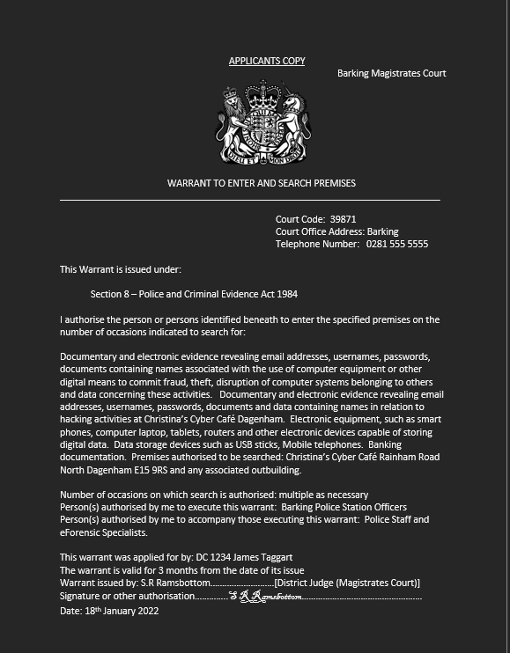

**4.3 Chain Of Custody**

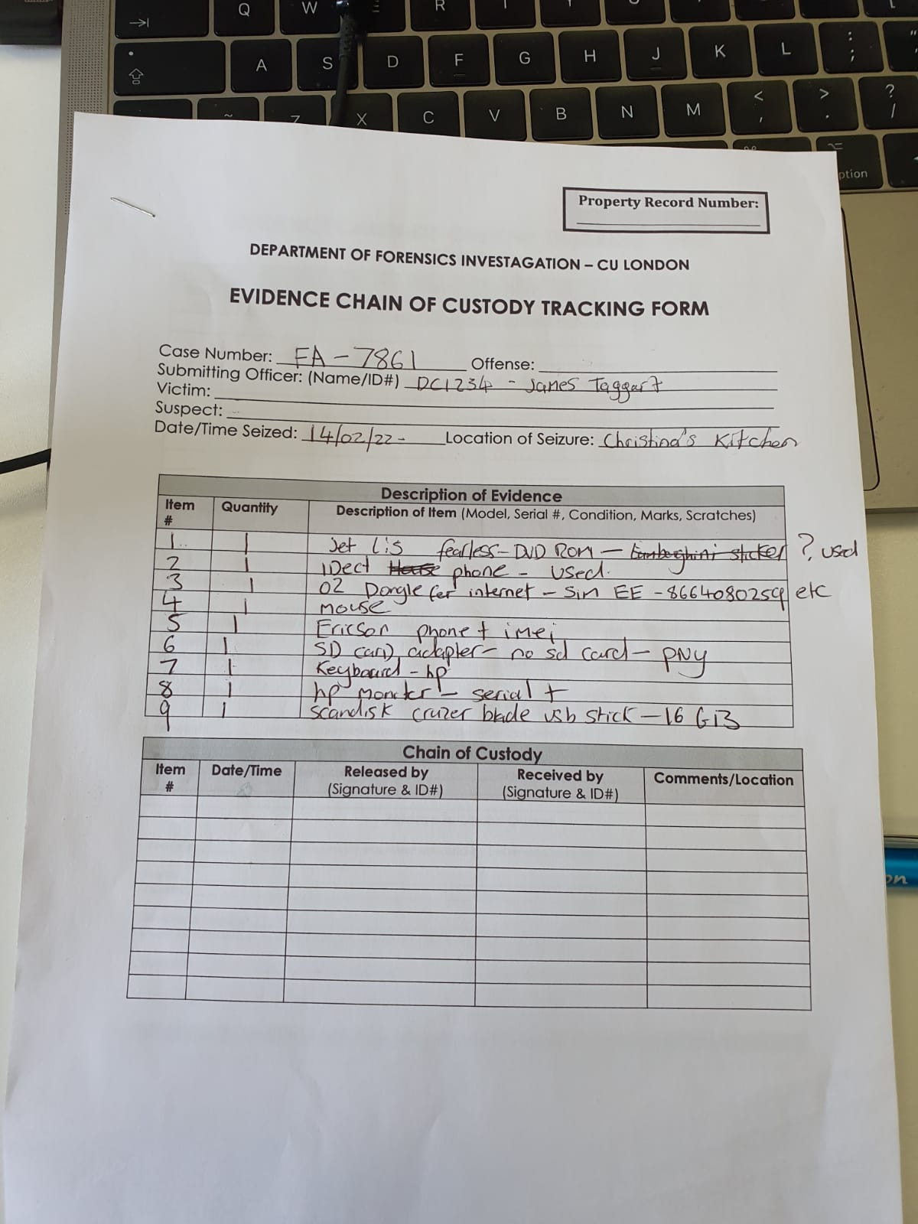

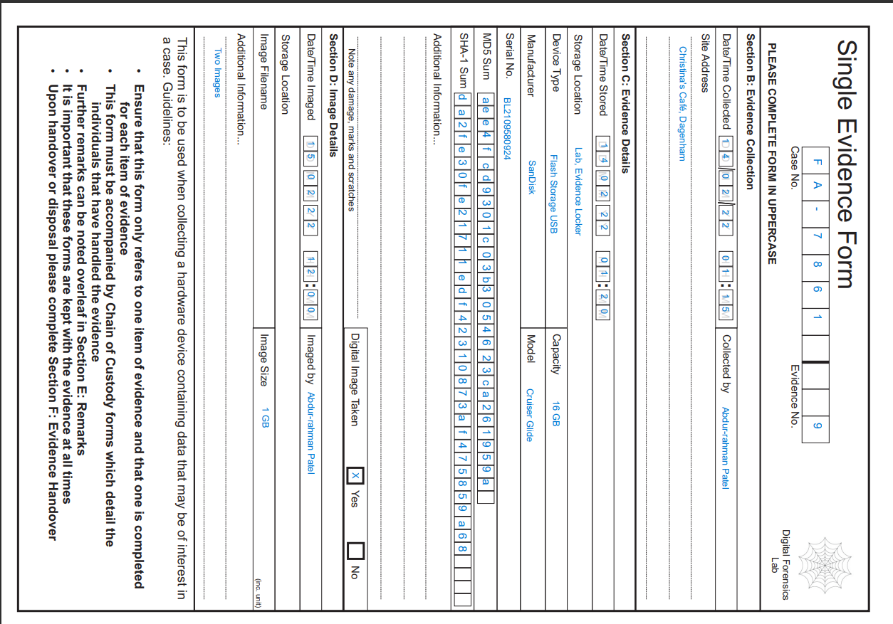

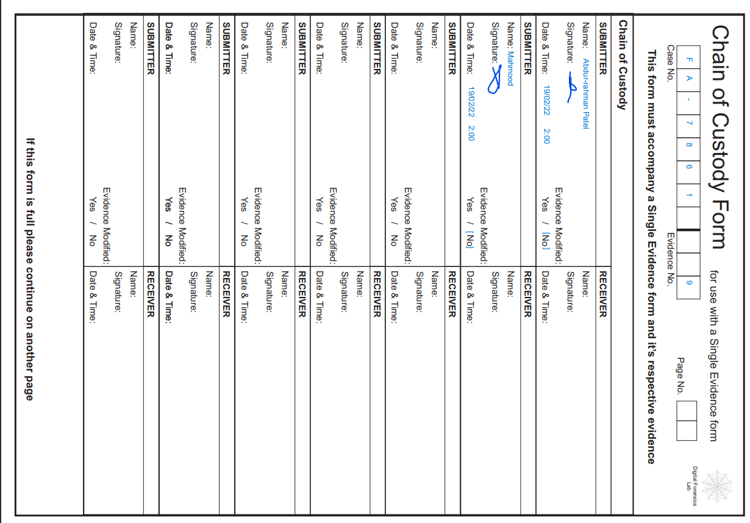

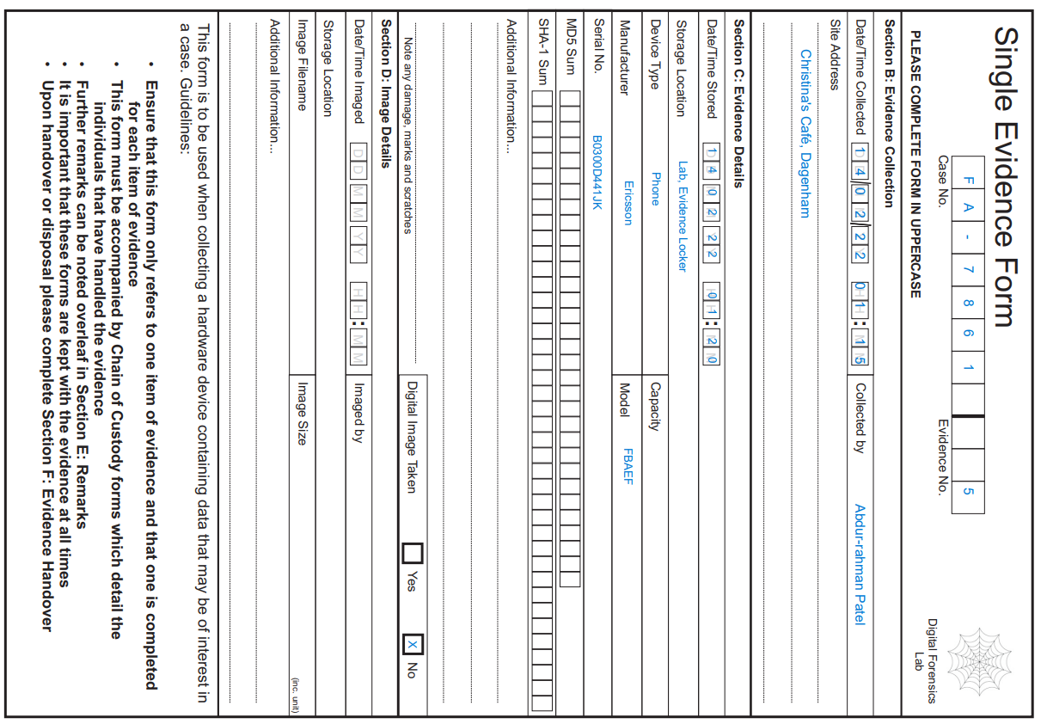

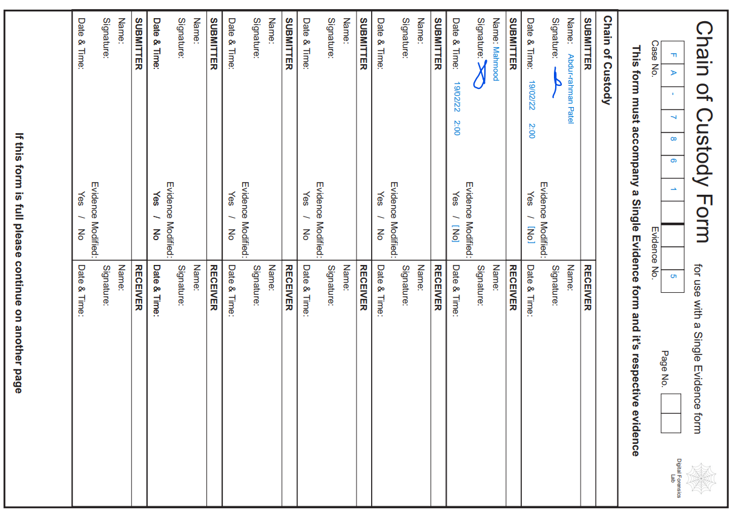

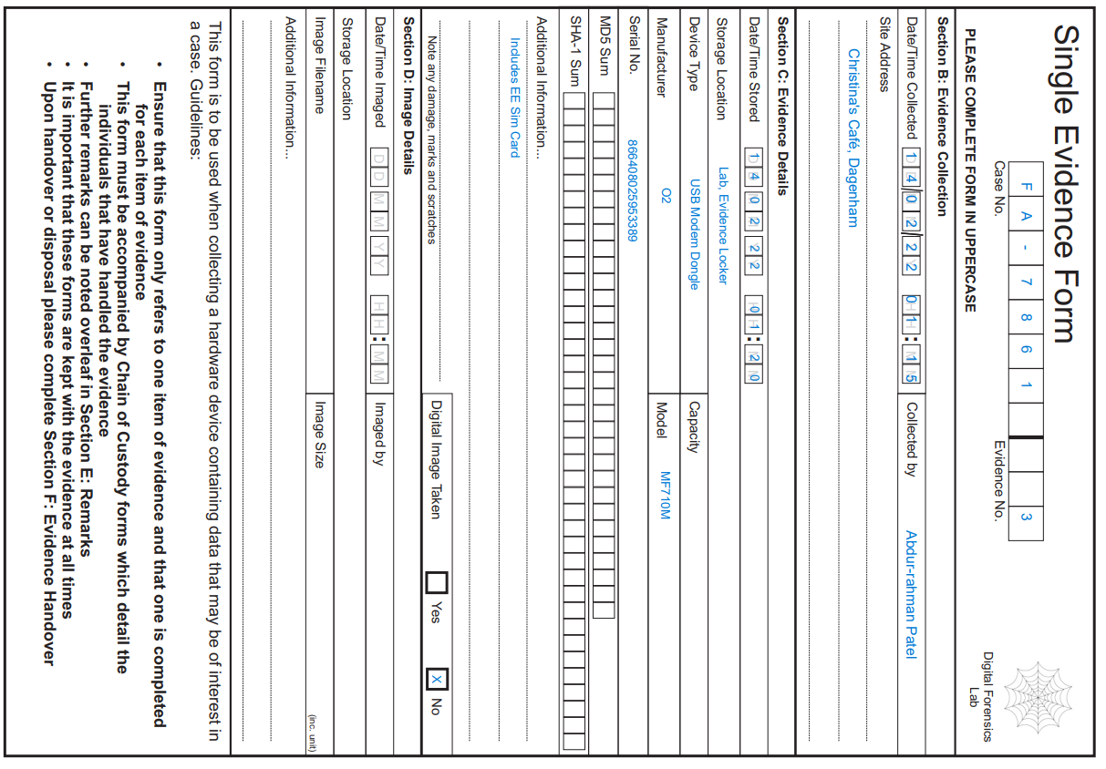

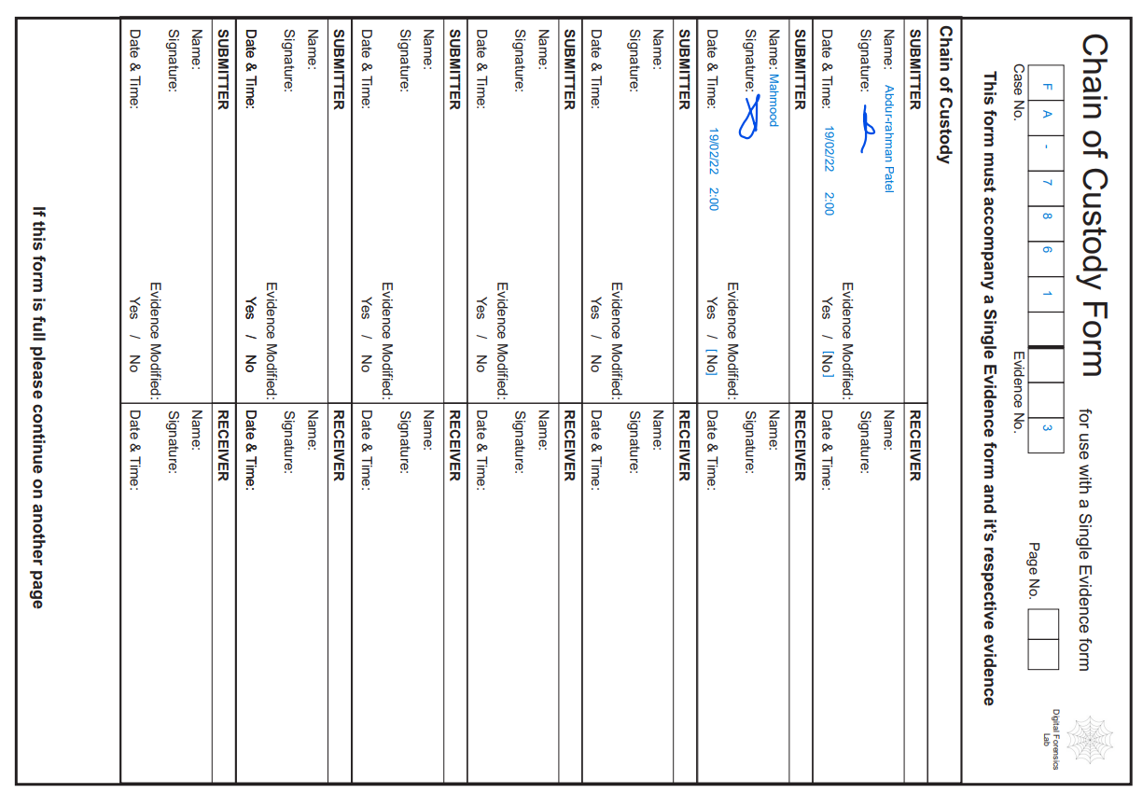

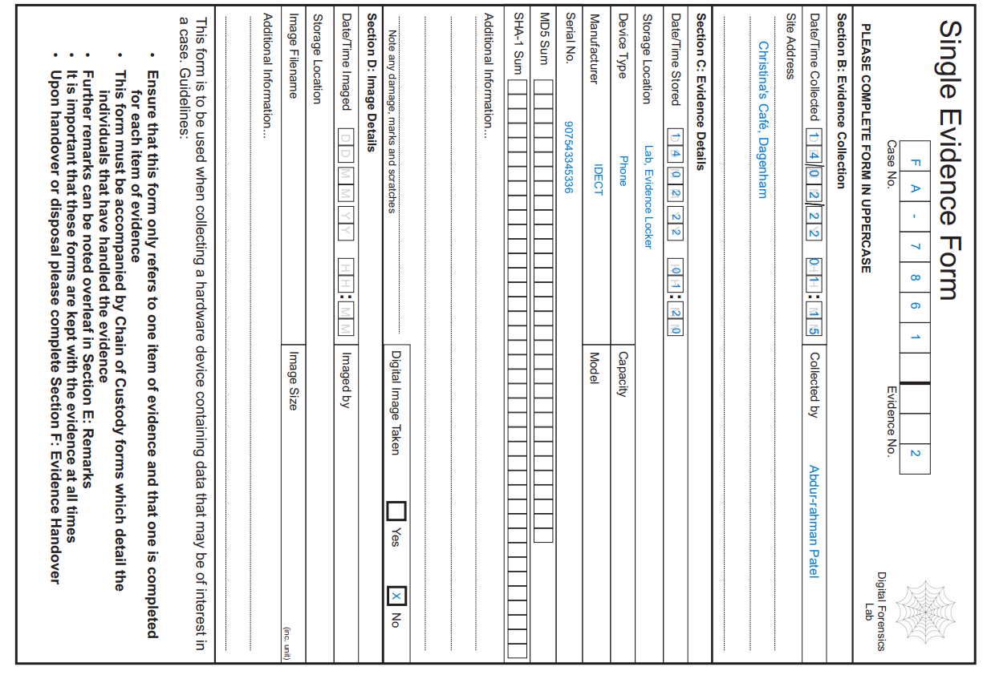

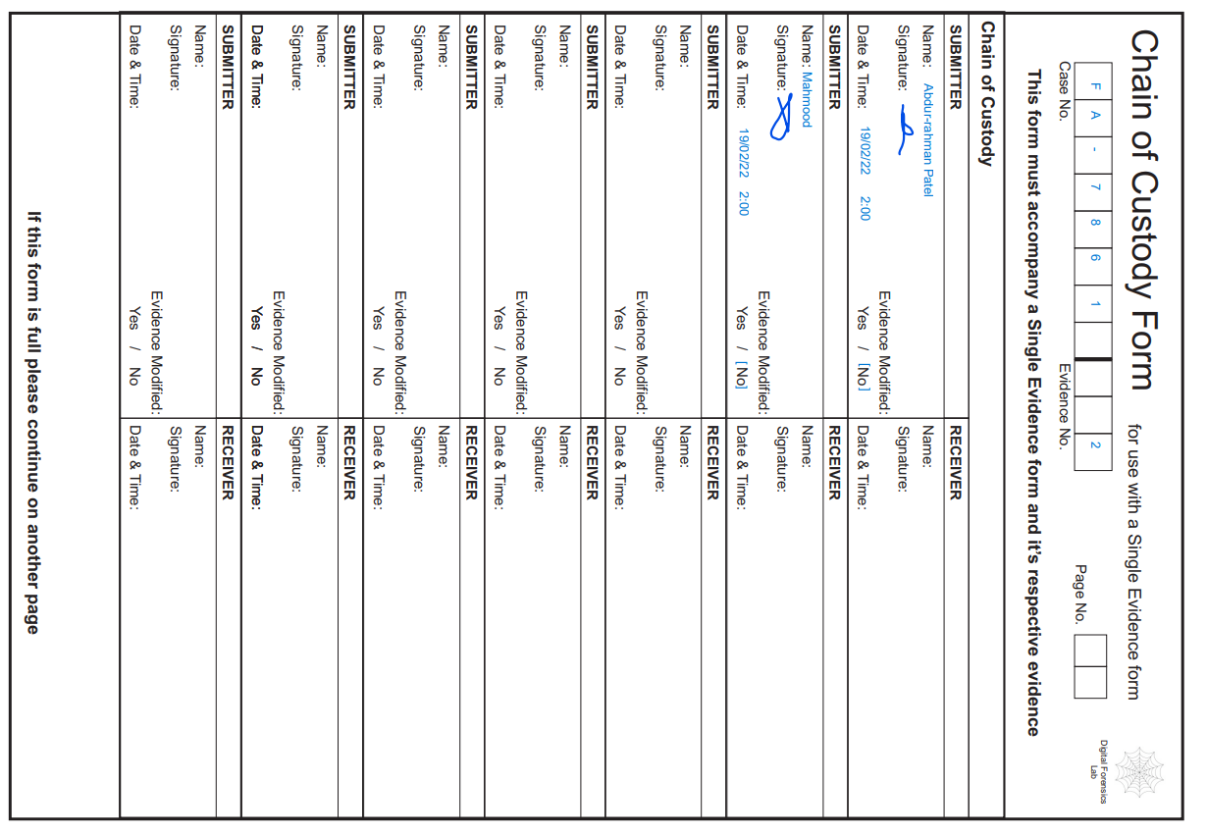

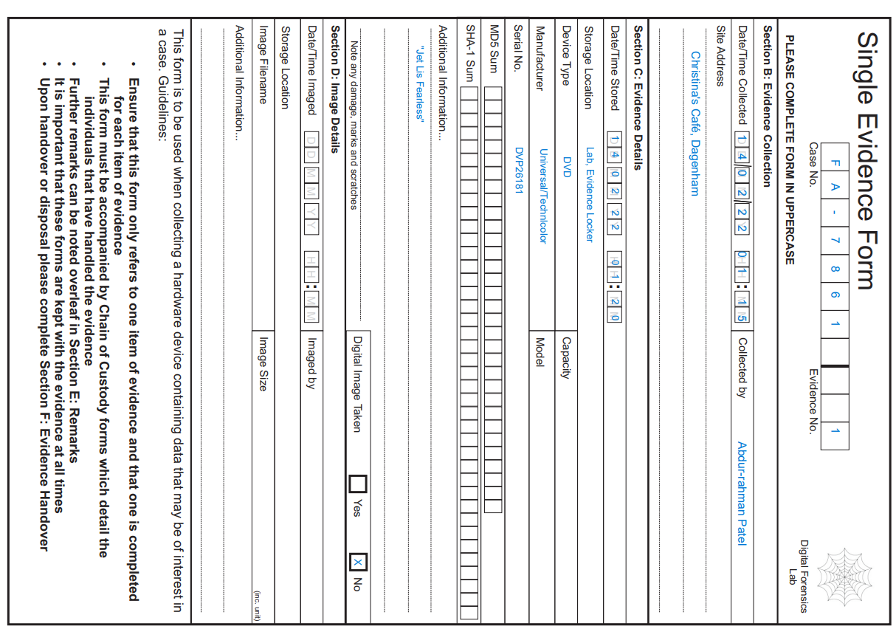

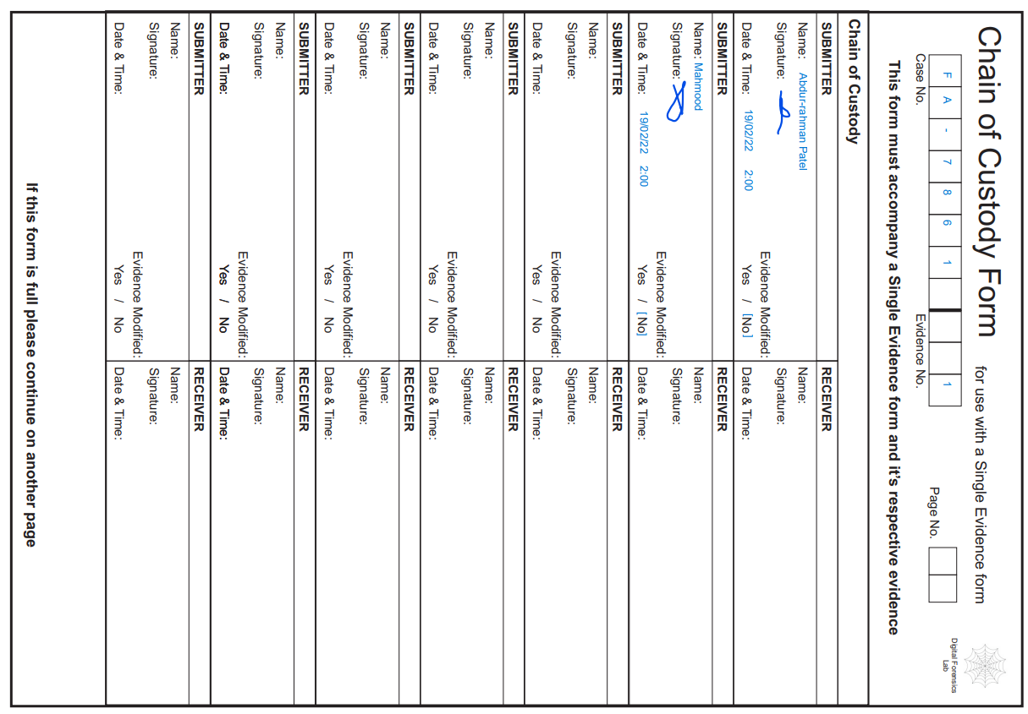

**4.4 Crime Scene Drawing and mapping**

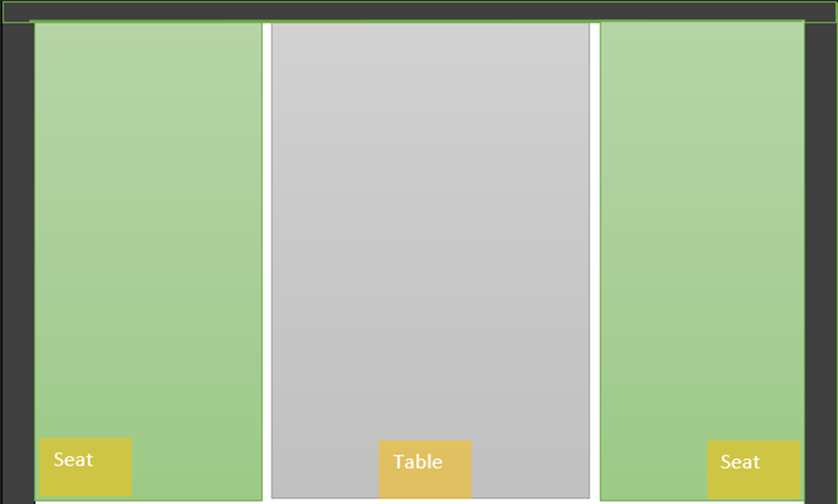

1 4.4 Basic Plan

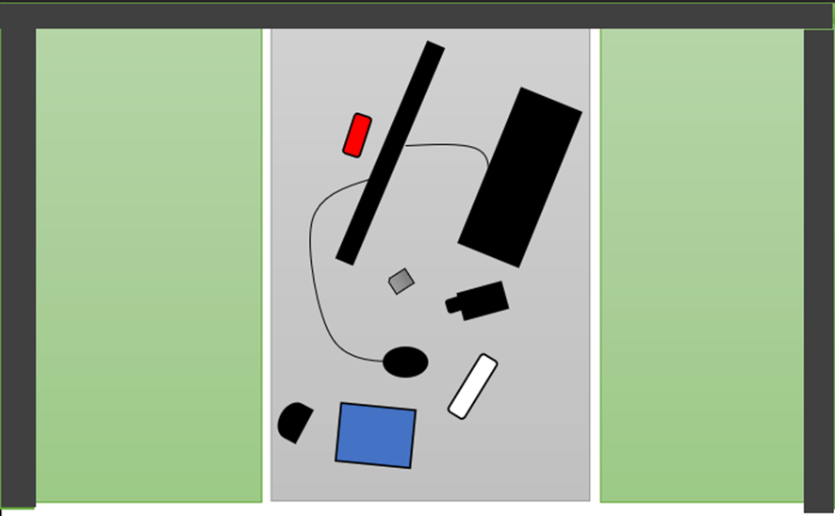

2 4.4 Evidence Plan

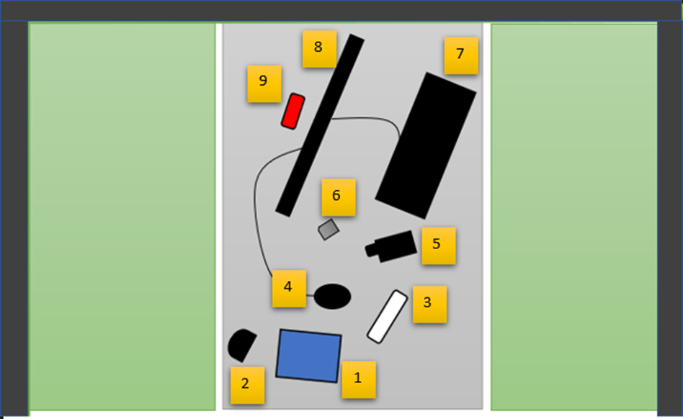

3 4.4 Evidence Plan Labelled

**4.5 Crime Scene Photographs**

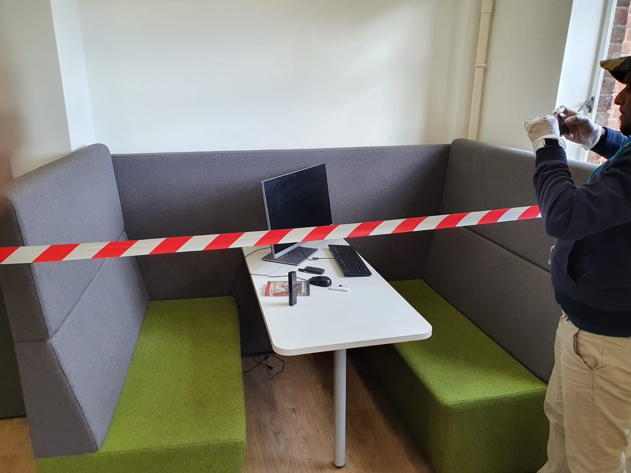

4 4.5 First Responder Scene Photo Angle 1

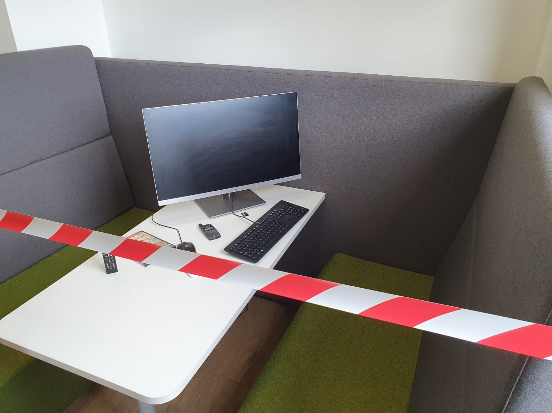

5 4.5 First Responder Scene Photo Angle 2

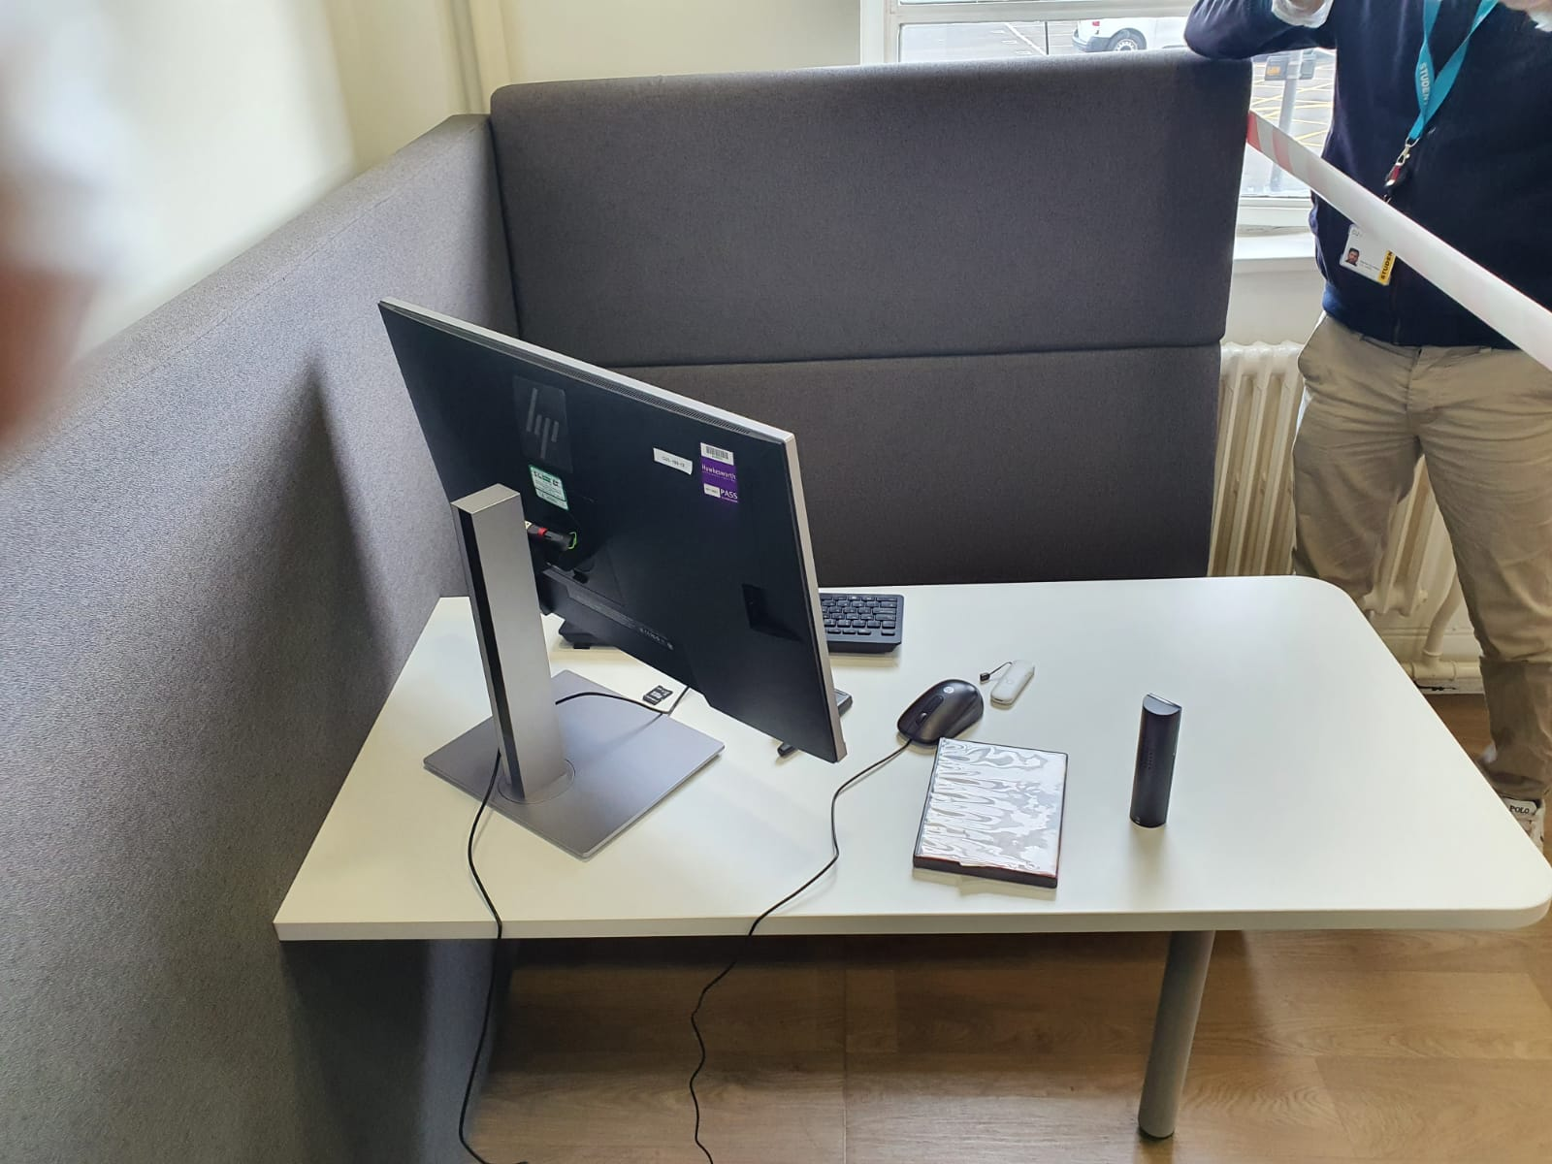

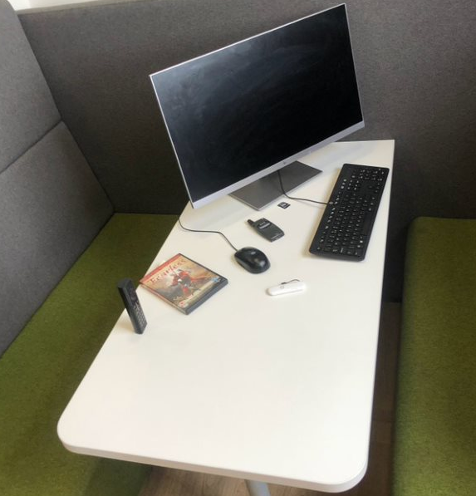

6 4.5 On Scene Angle 1

7 4.5 On Scene Angle 2

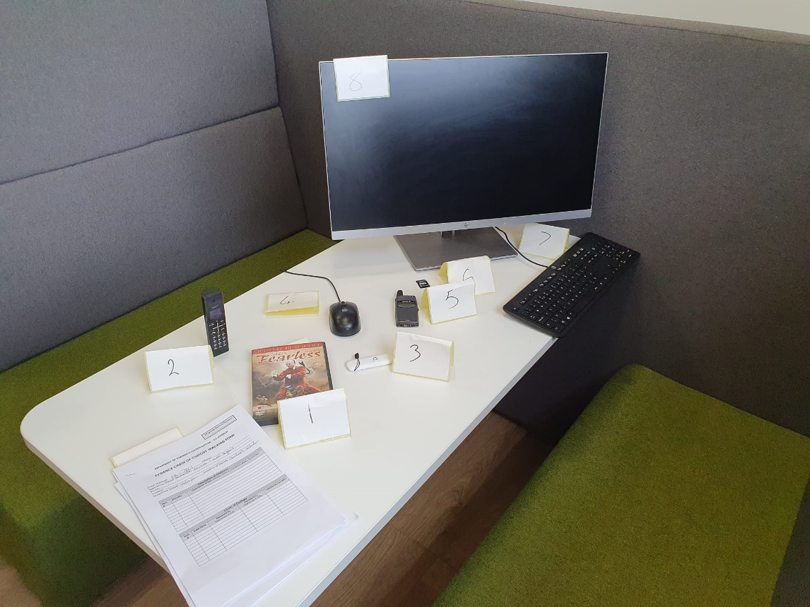

8 4.5 On Scene Labelled Angle 1

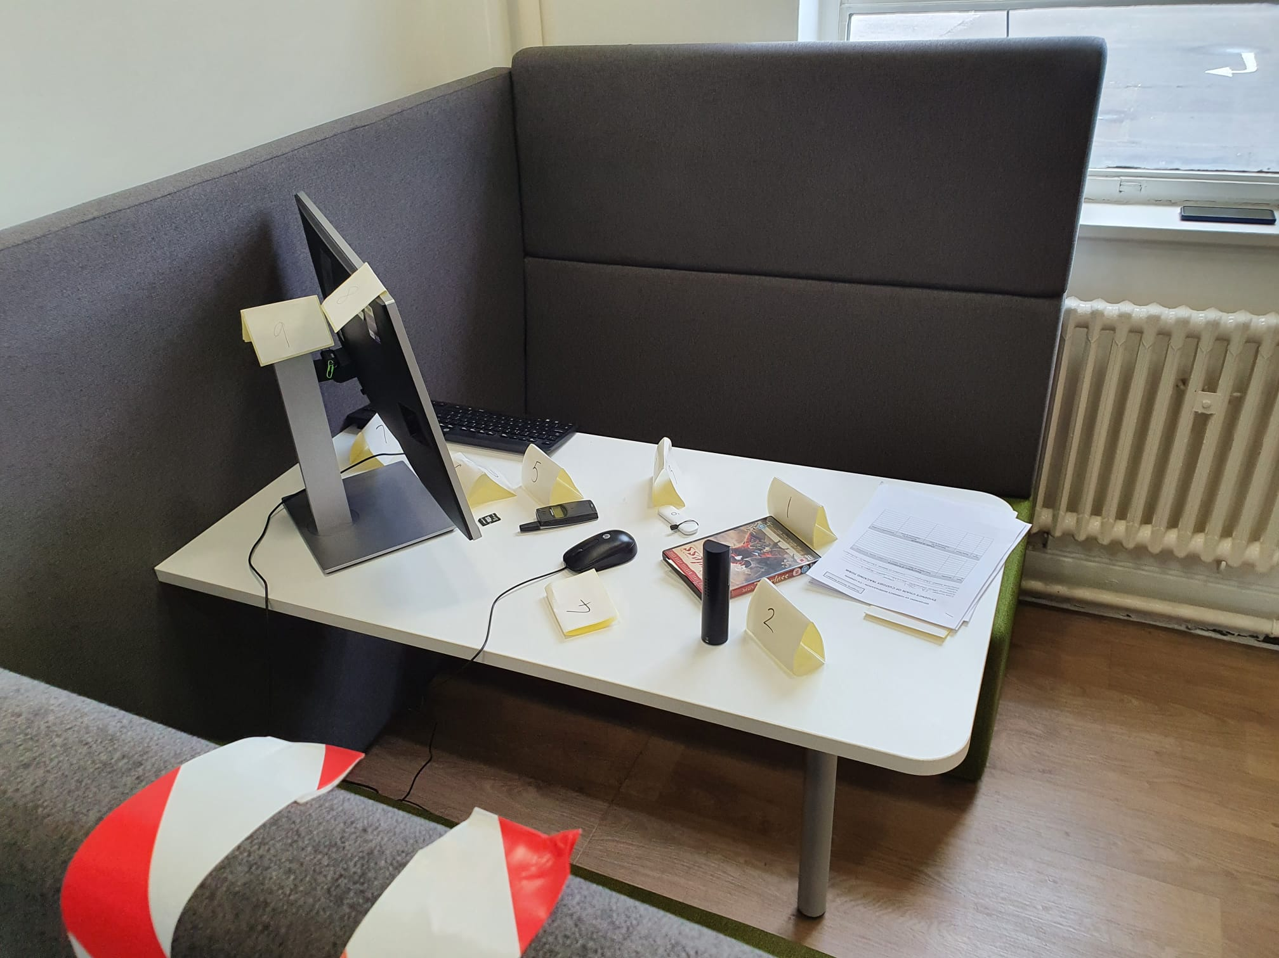

9 4.5 On Scene Labelled Angle 2

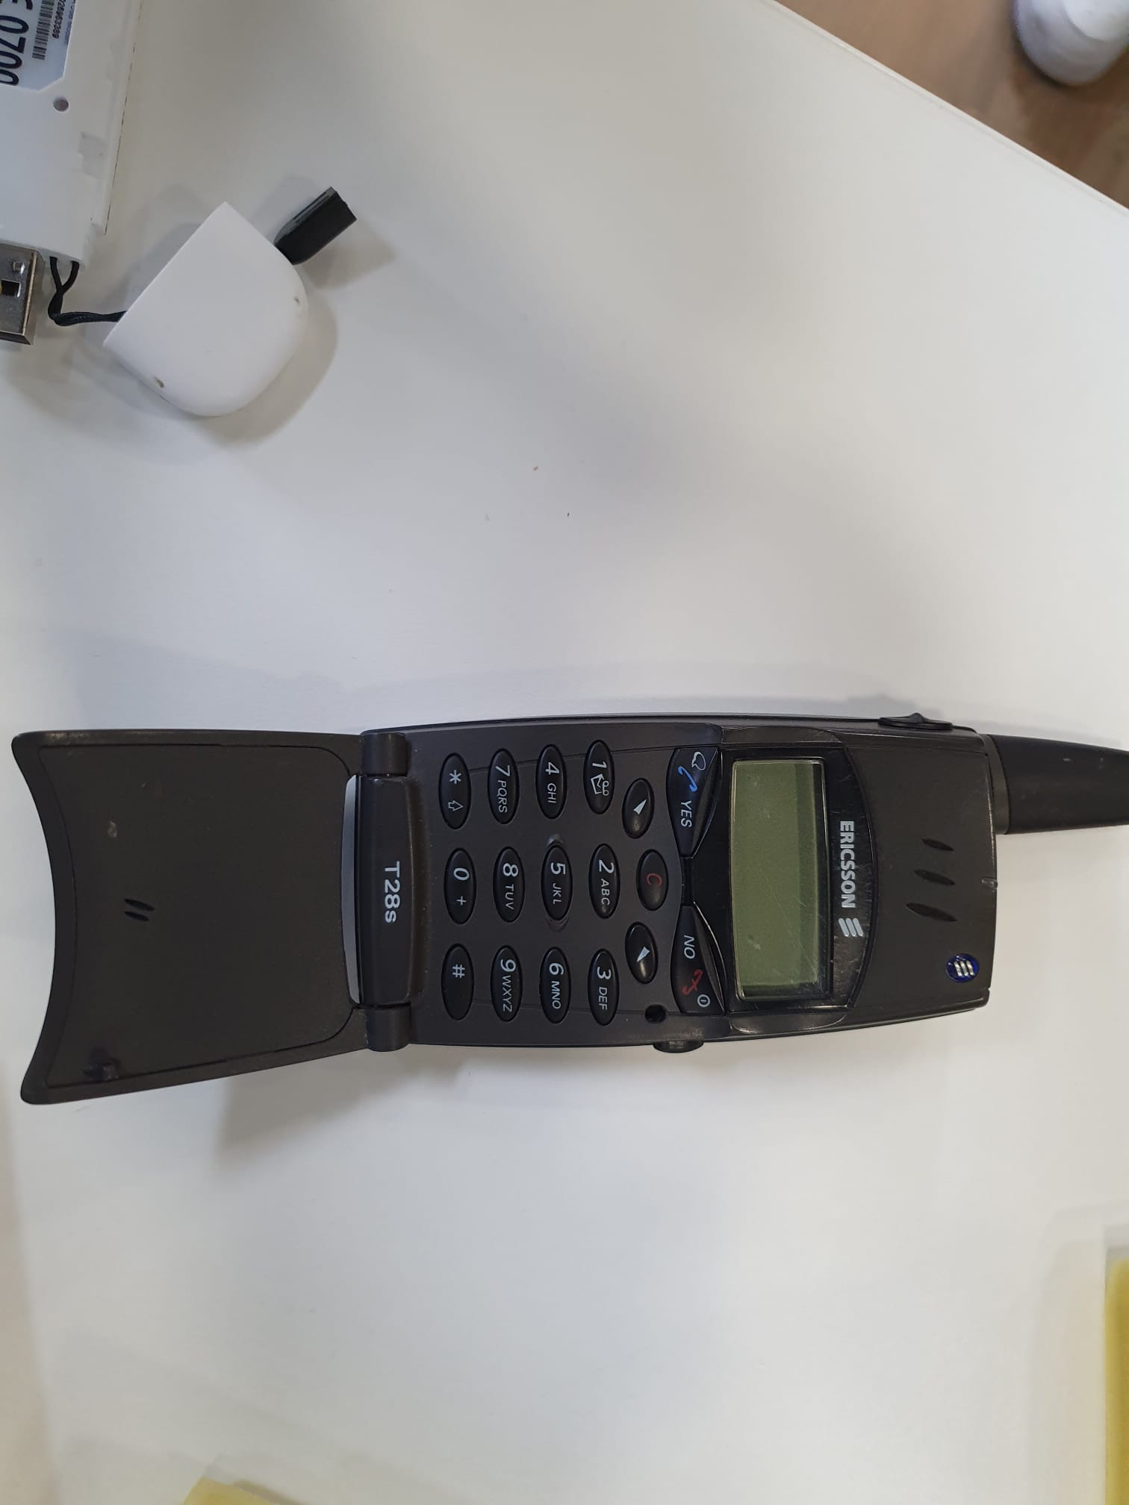

10 4.5 Ericsson Mobile

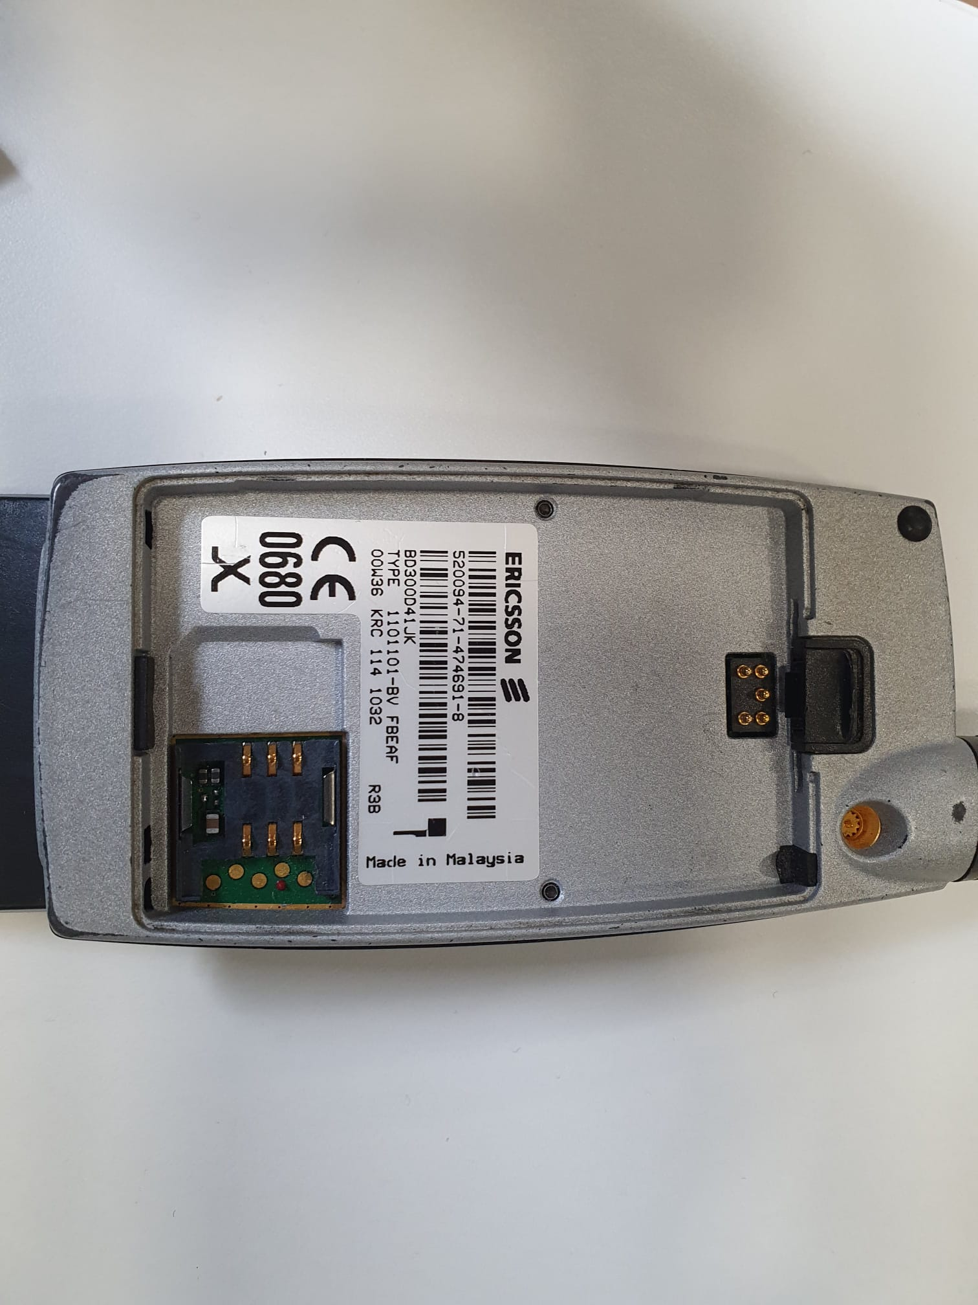

11 4.5 Ericsson Mobile Identification Codes

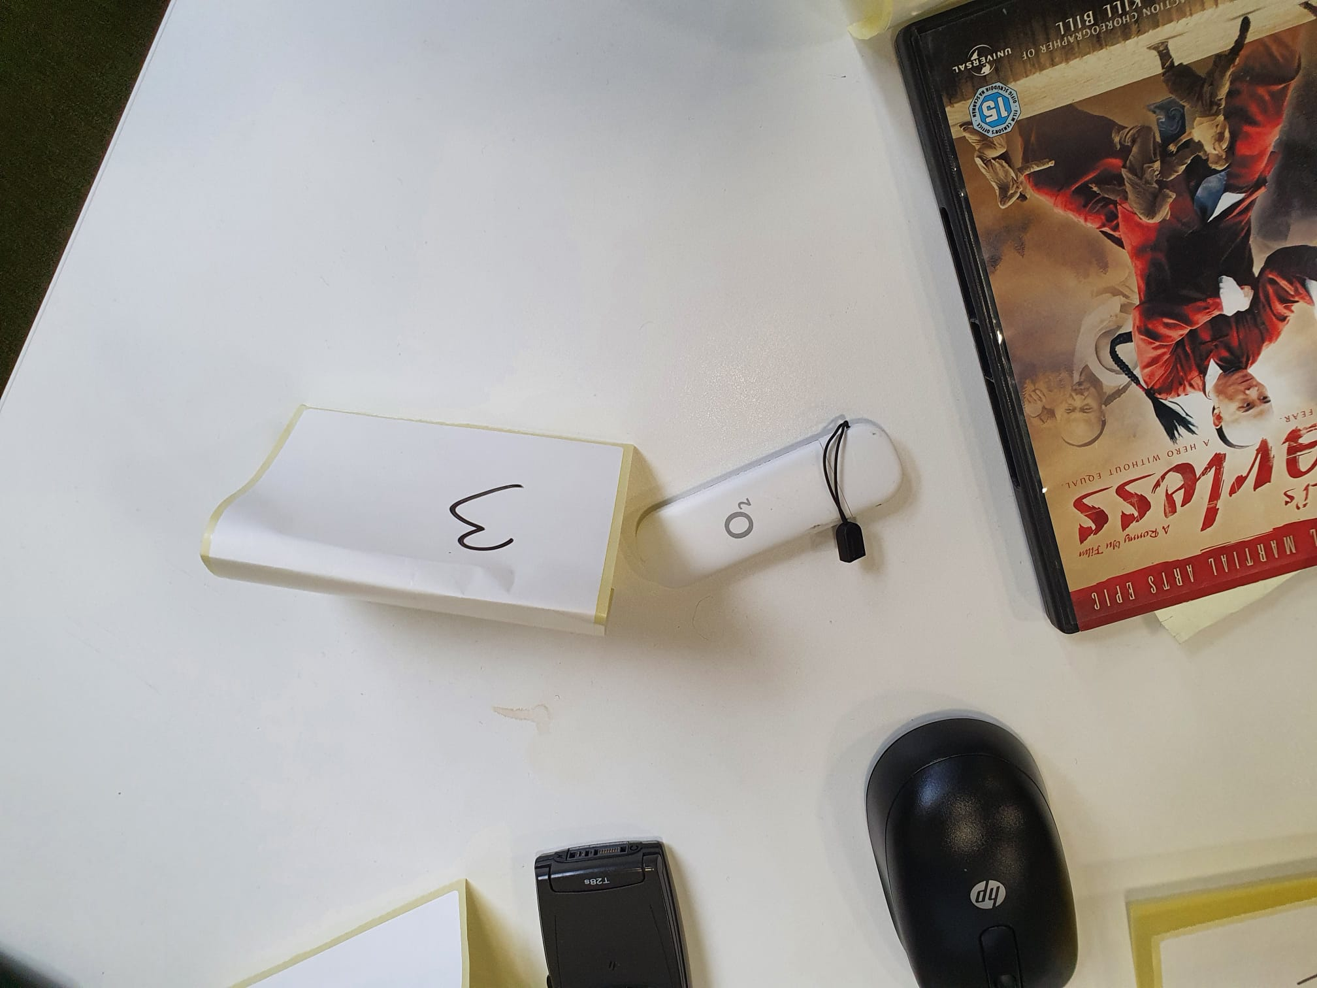

12 4.5 O2 Dongle

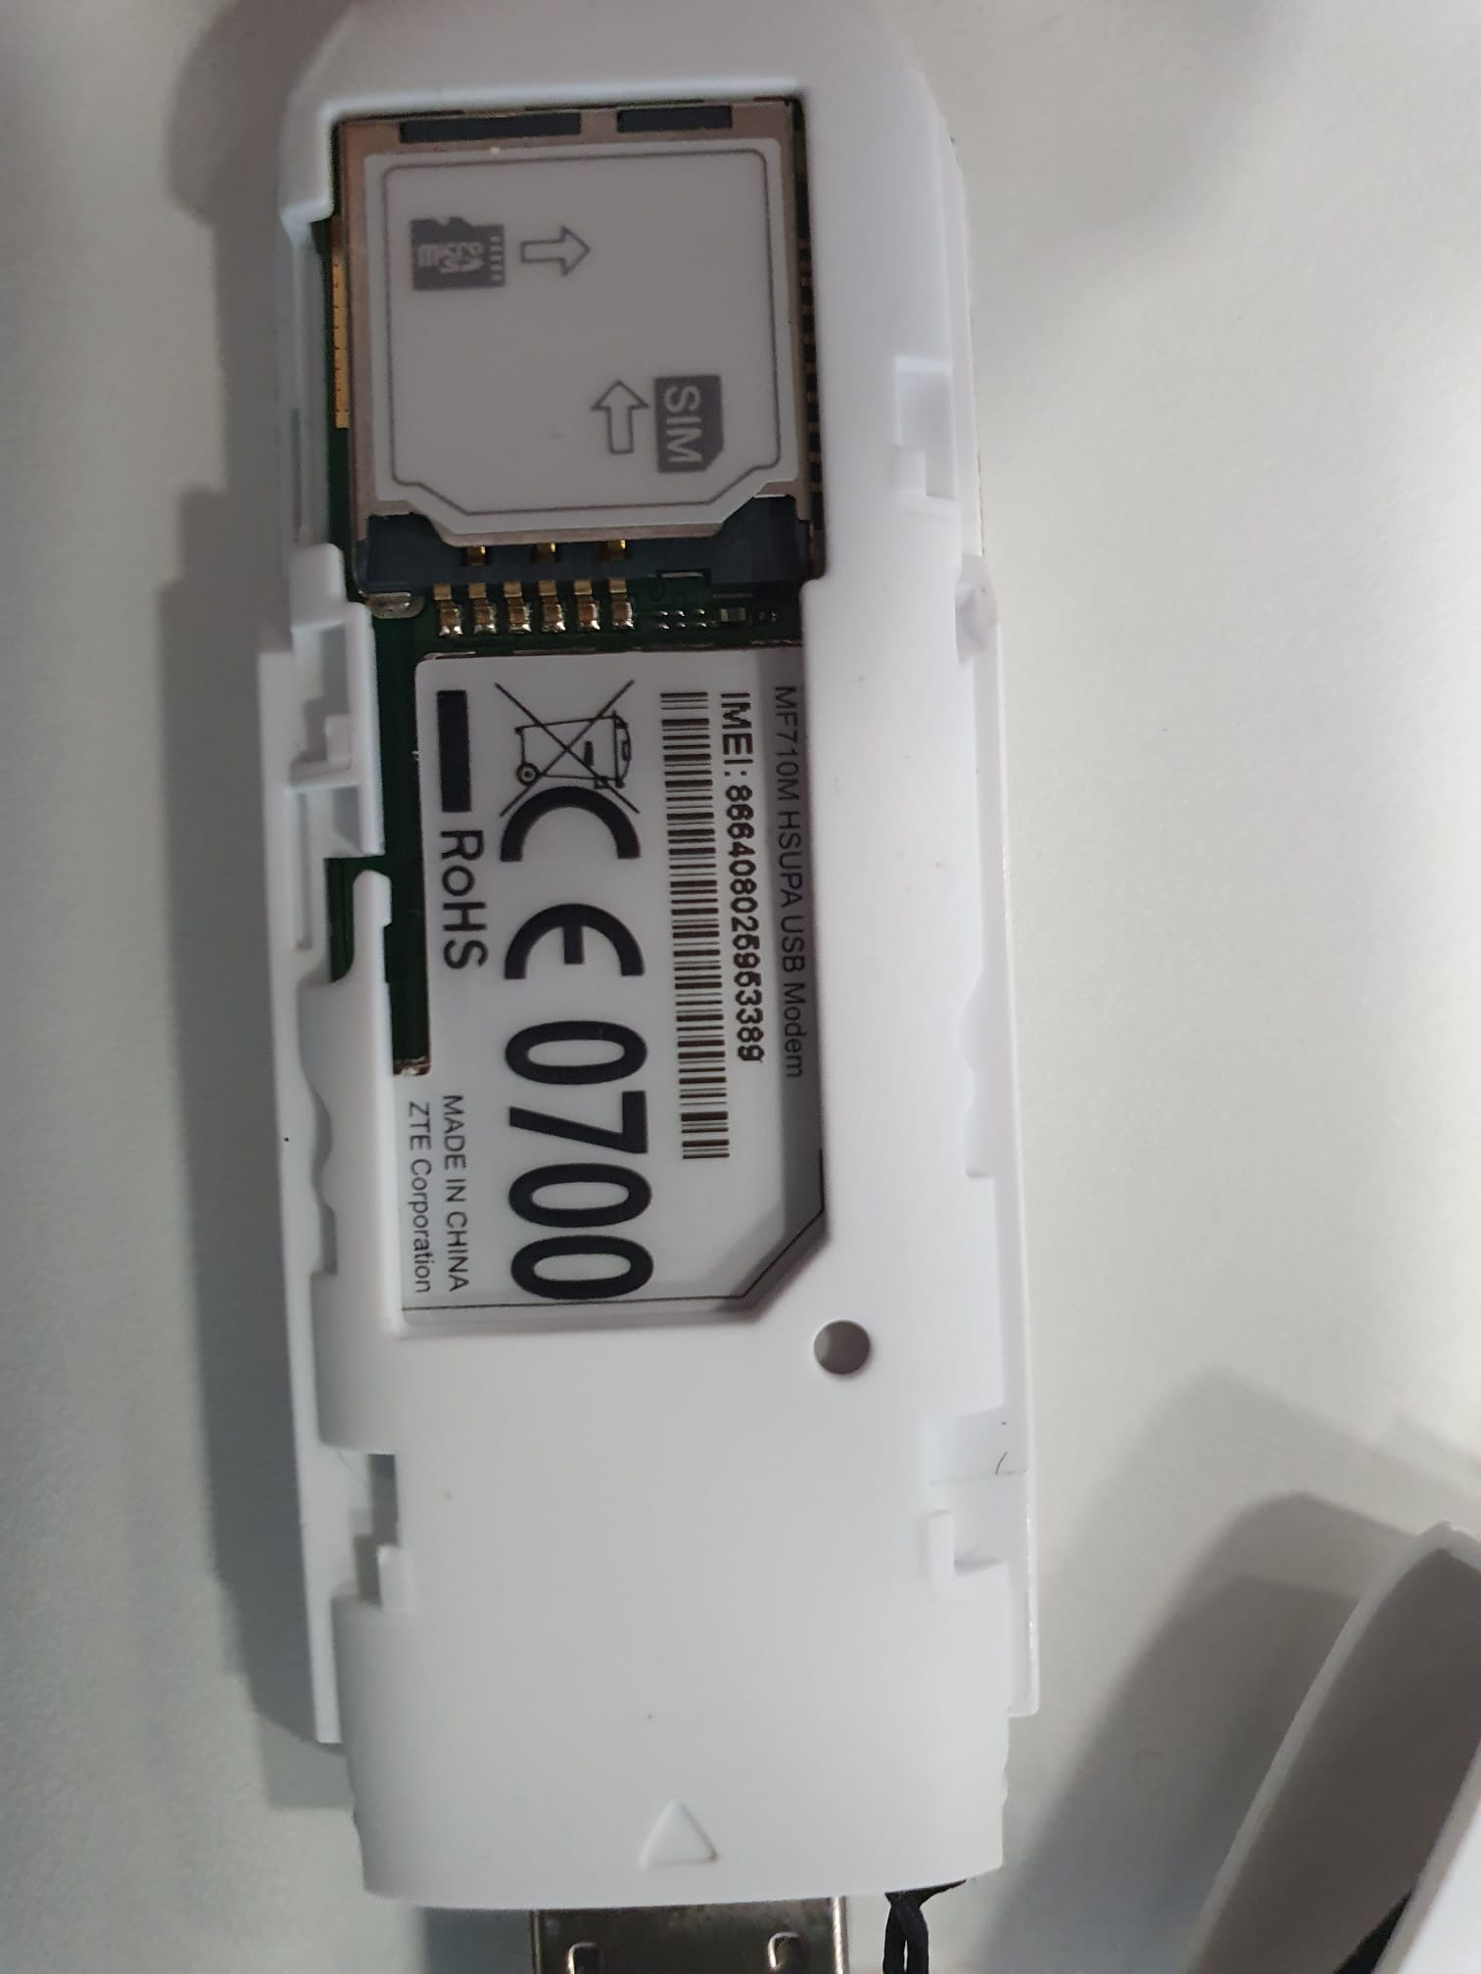

13 4.5 O2 Dongle Identification Codes

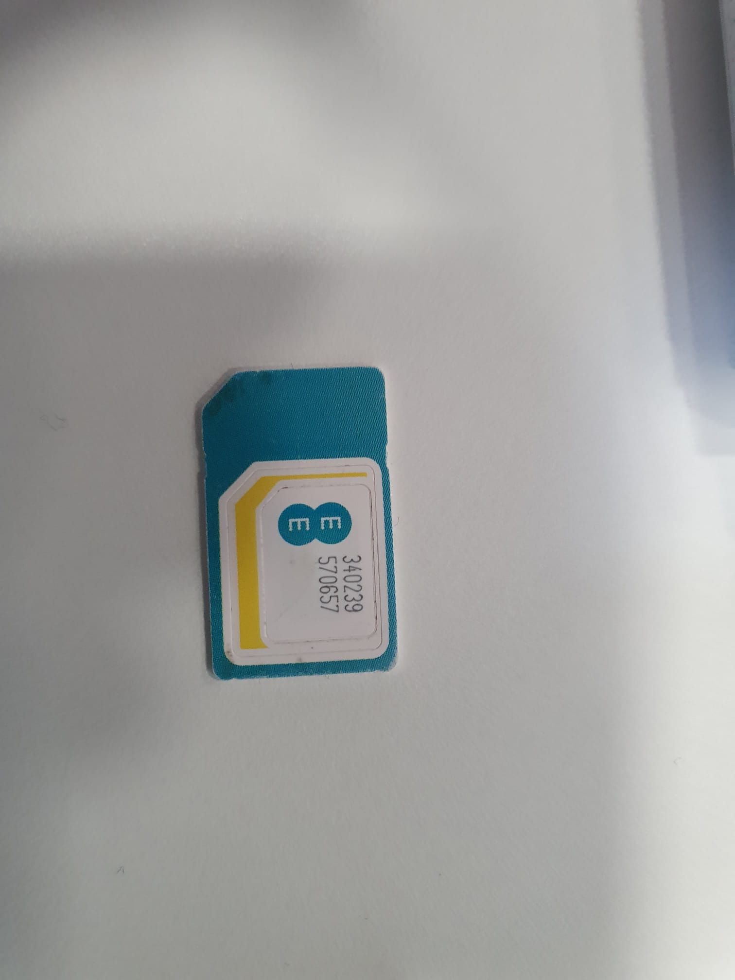

14 4.5 EE Sim Card

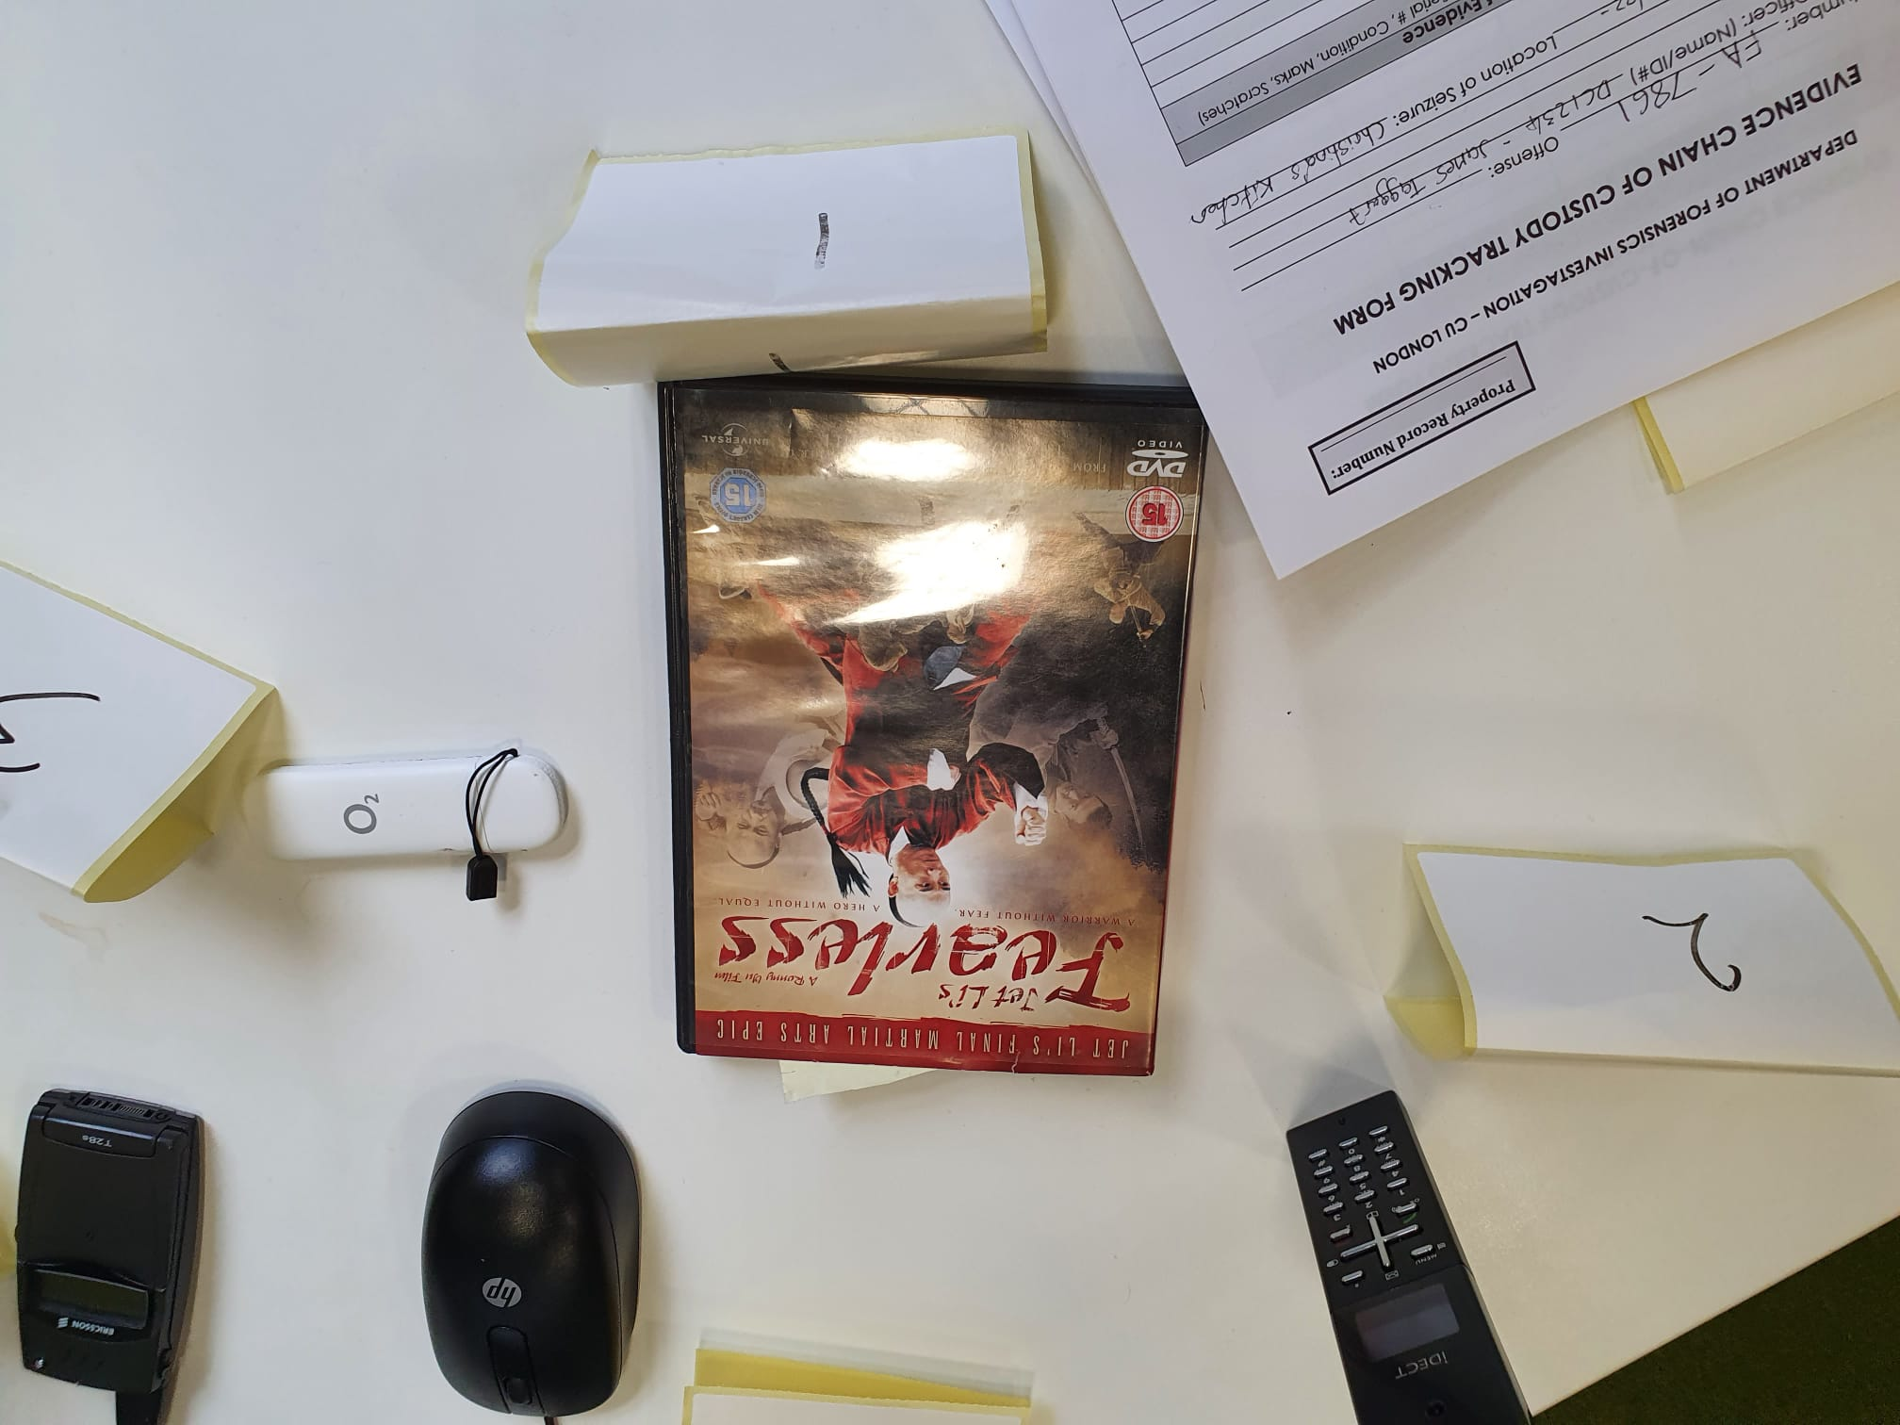

15 4.5 Jet Lis DVD Video

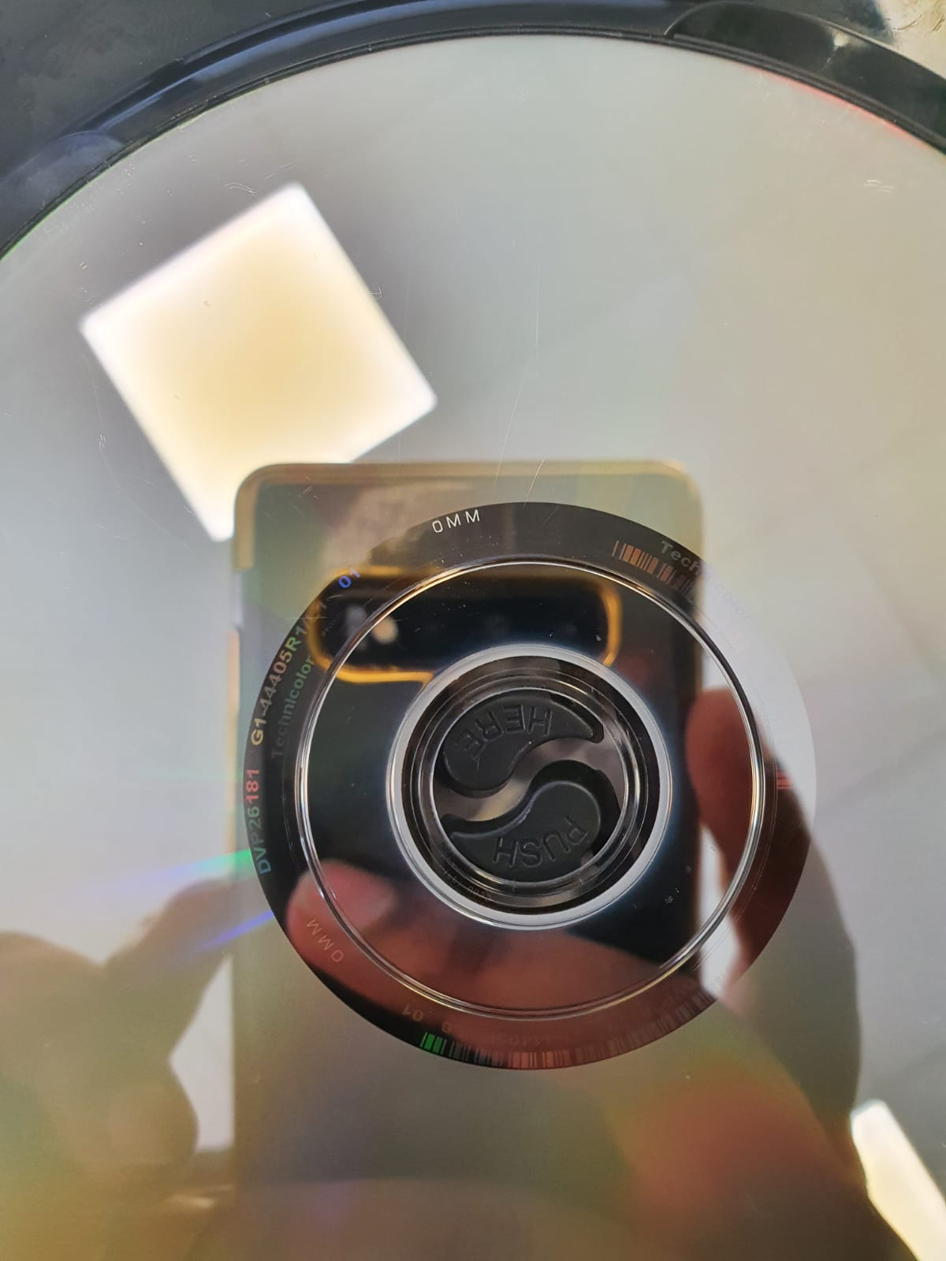

16 4.5 Jet Lis DVD Video CD Identification Codes



17 4.5 IDECT Phone

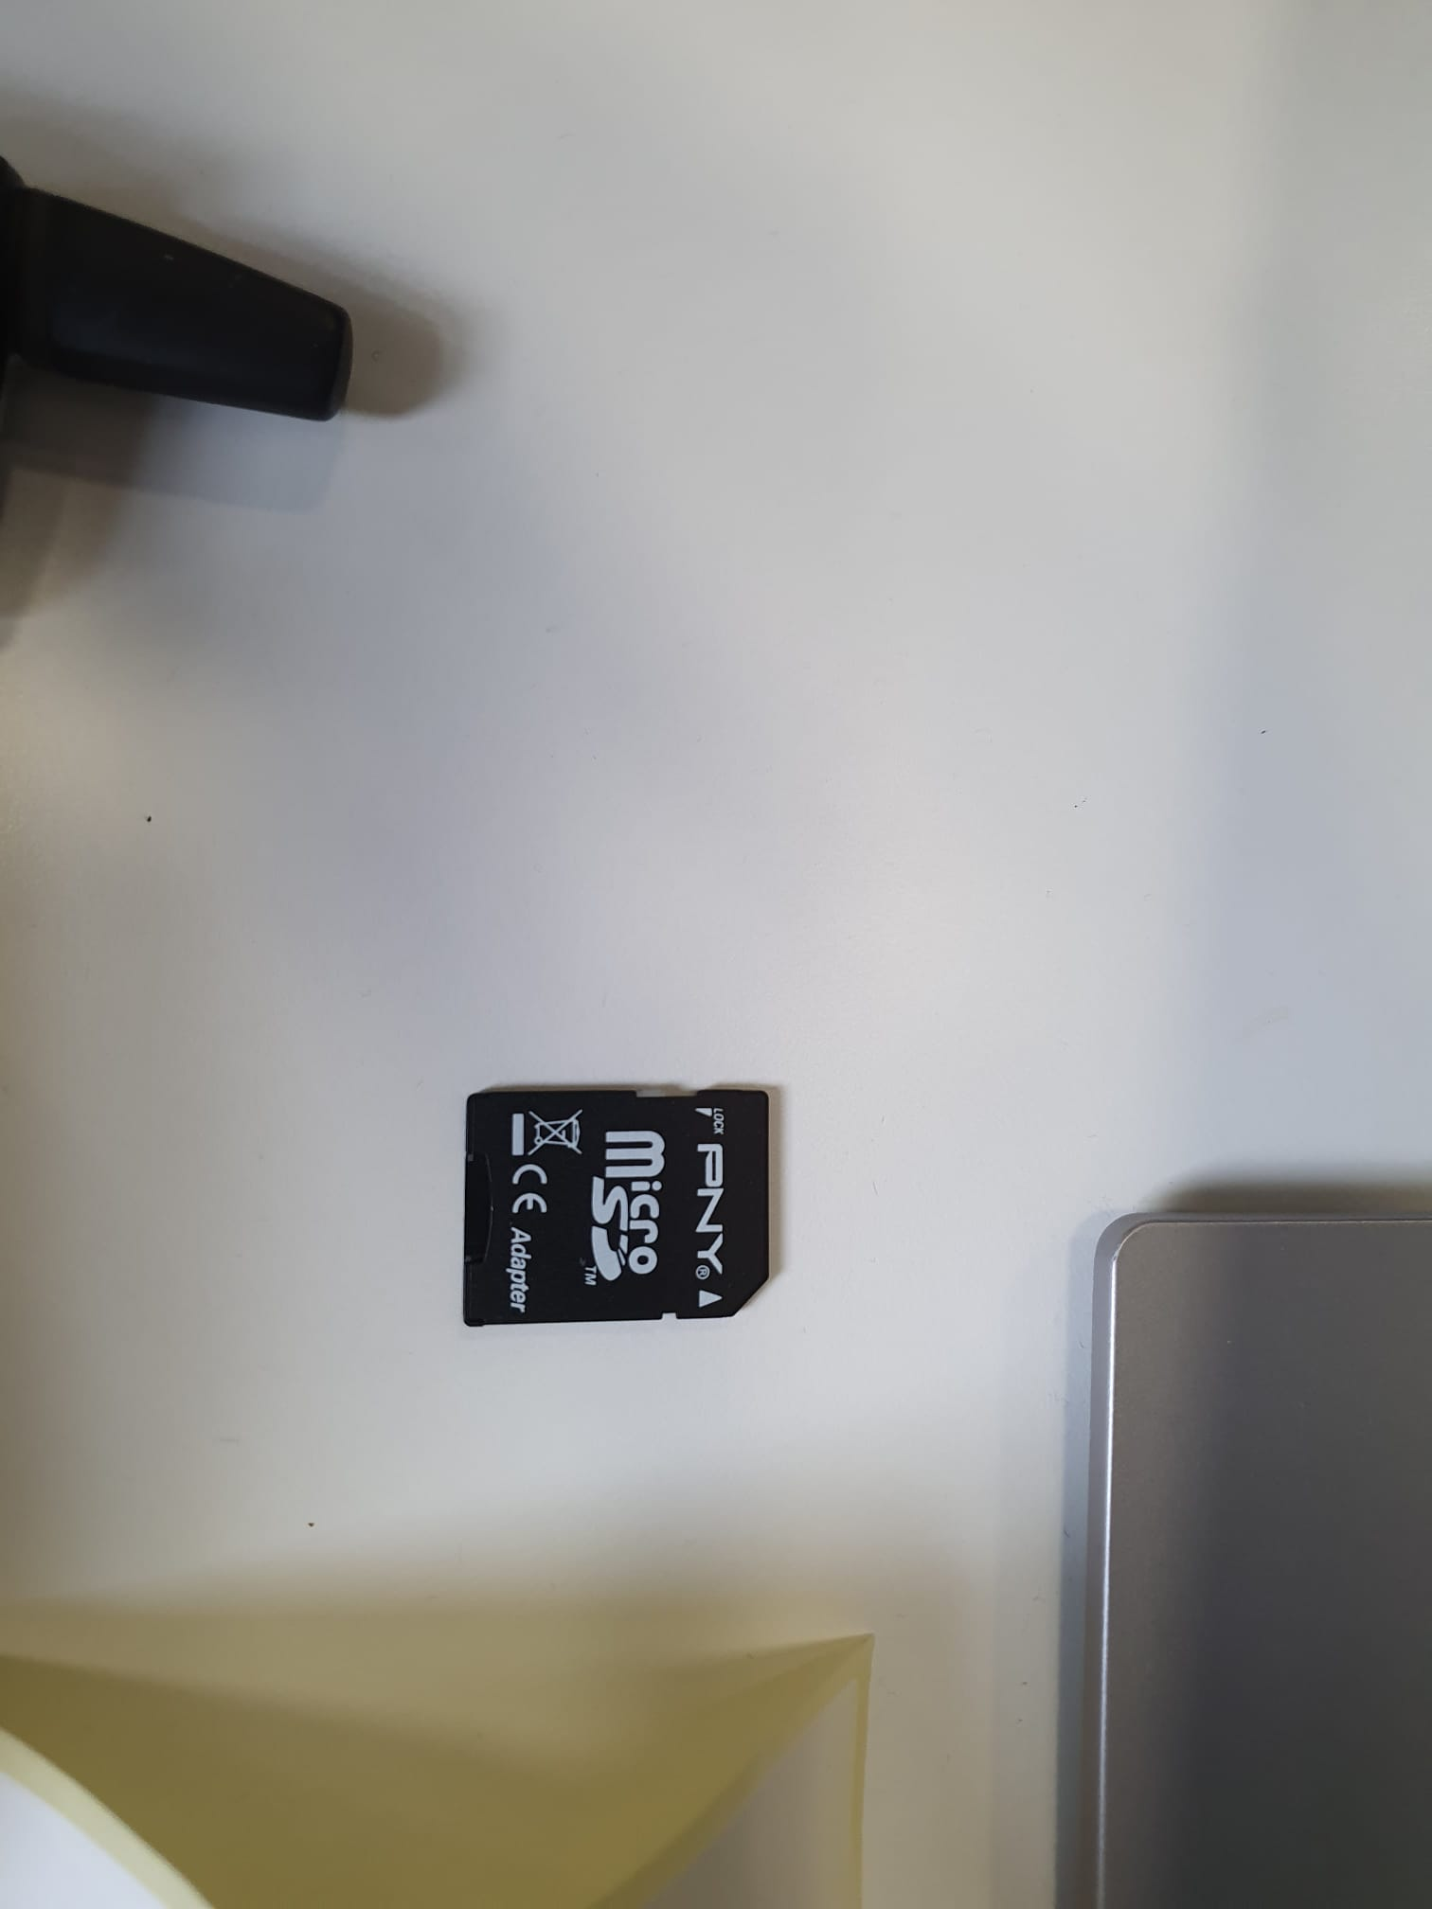

18 4.5 PNY SD Card Adapter

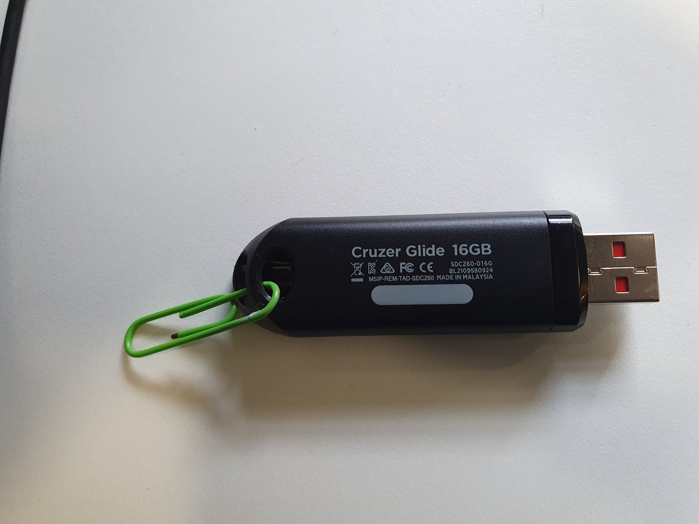

4.5 SanDisk Cruzer Glide 16GB USB/ Identification Codes

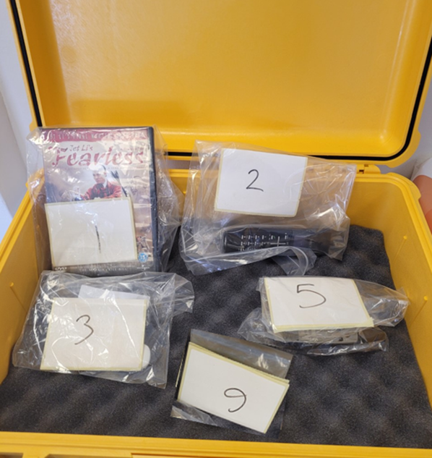

4.5 Evidence Case

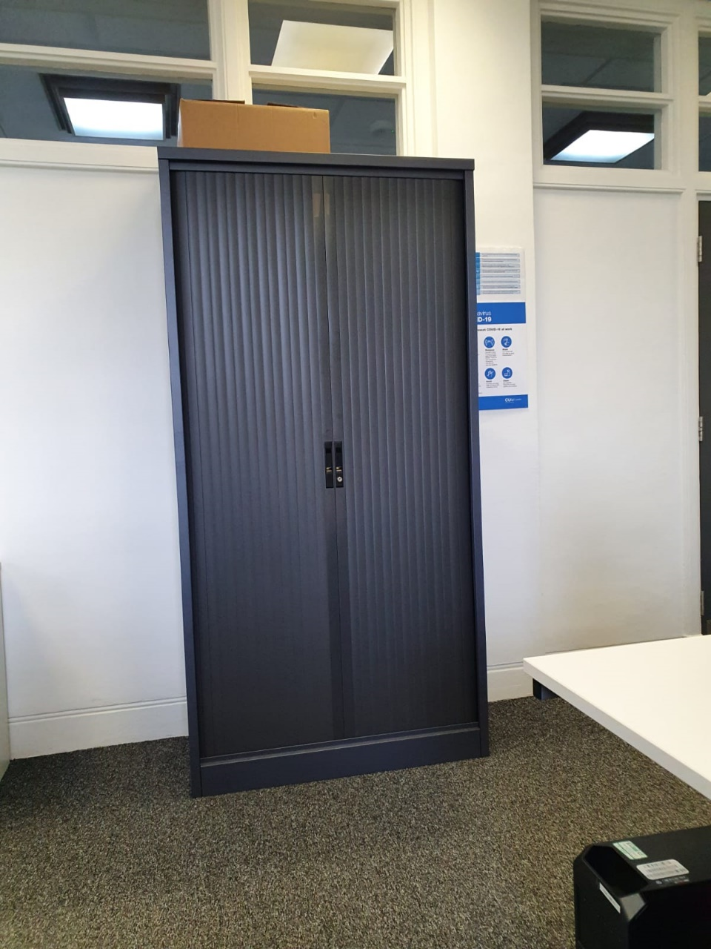

19 4.5 Evidence Locker

**4.6 Image Analysis**

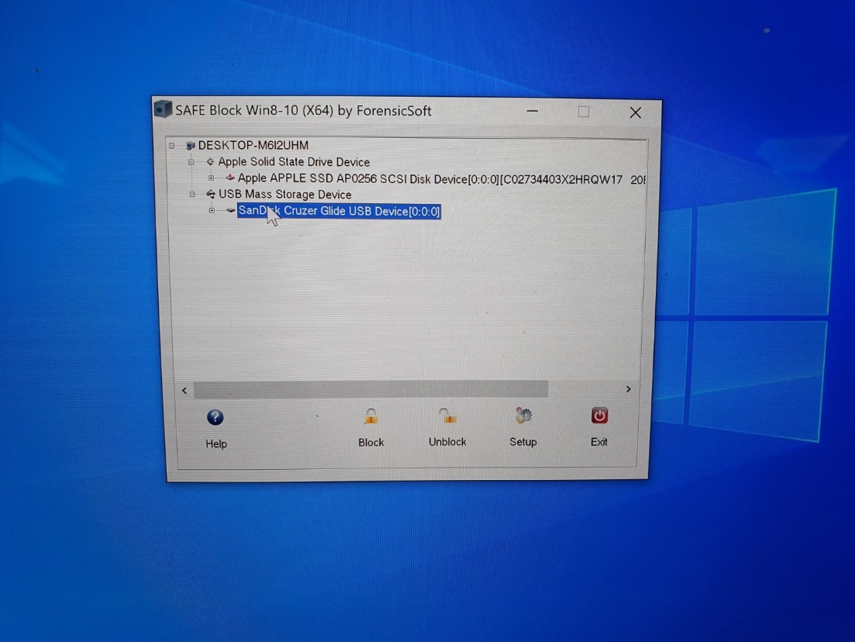

20 4.6 Safe Block

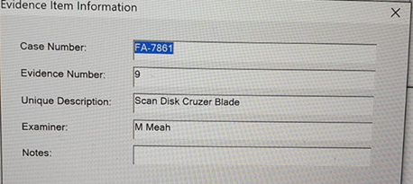

21 4.6 Case Setup

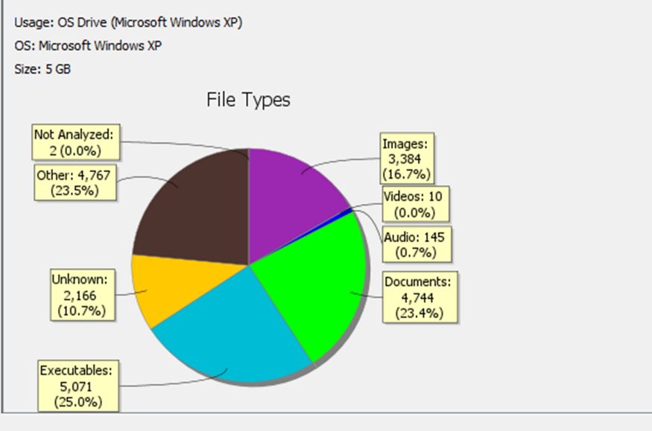**4.6.1 EVIDENCE CLASS – HARWARE AND SYSTEM**

22 4.6.1 File Types

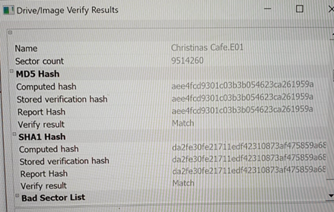

23 4.6.1 Hash

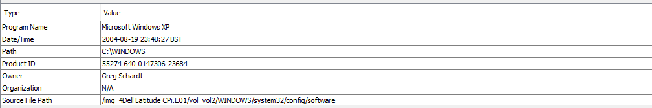

24 4.6.1 System Information

**4.6.2 EVIDENCE CLASS – IDENTITY**

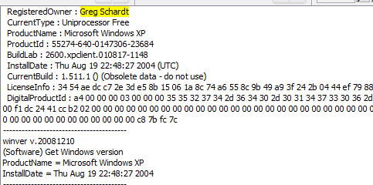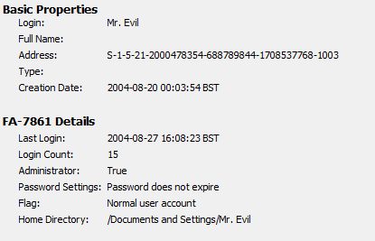

25 4.6.2 Owner information

26 4.6.2 Basic Login Information

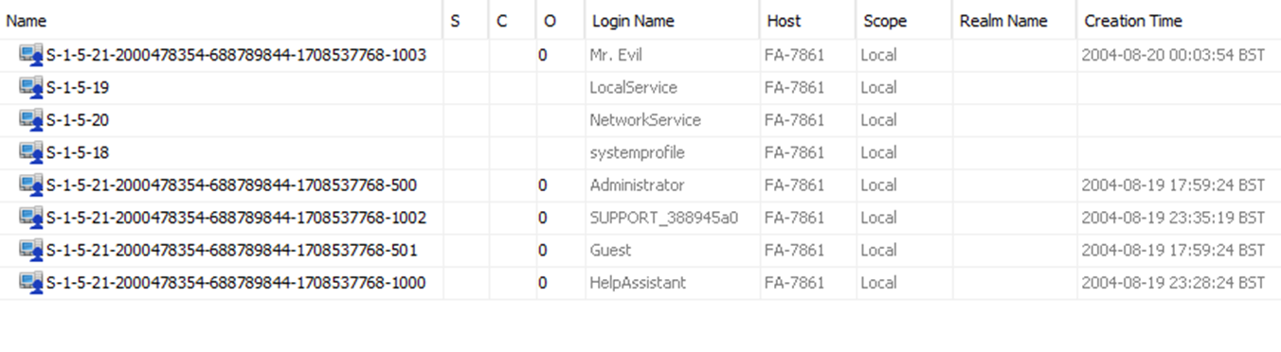

27 4.6.2 Account Information

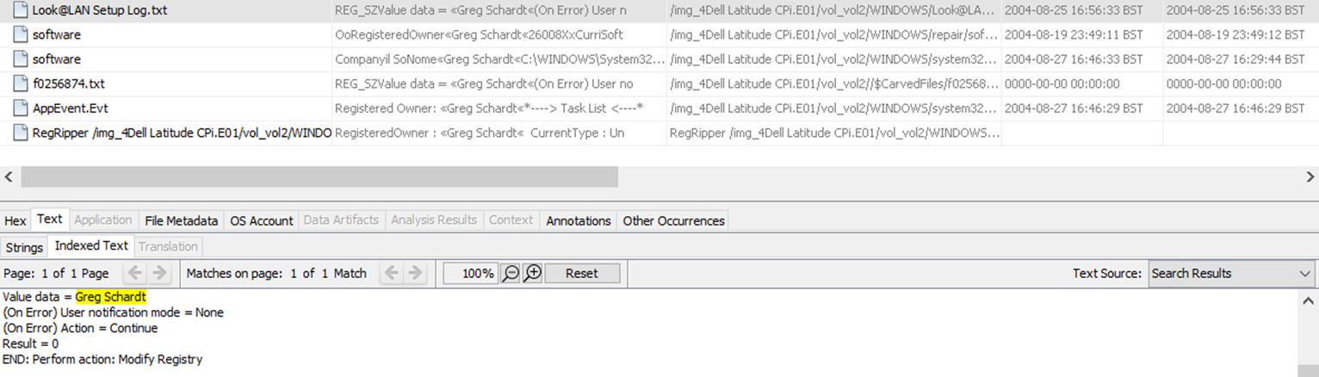

28 4.6.2 Look@Lan Program Registered Owner



29 4.6.2 Product ID and Name

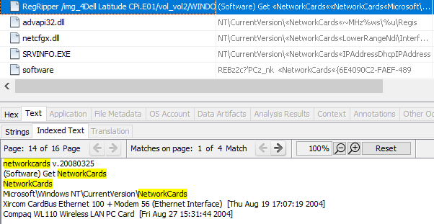

30 4.6.2 Network Cards

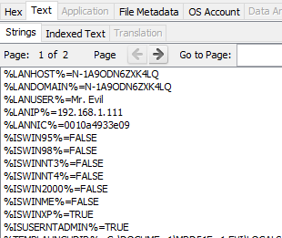

31 4.6.2 IP Addresses

**4.6.3 EVIDENCE CLASS – ONLINE ACTIVITY**

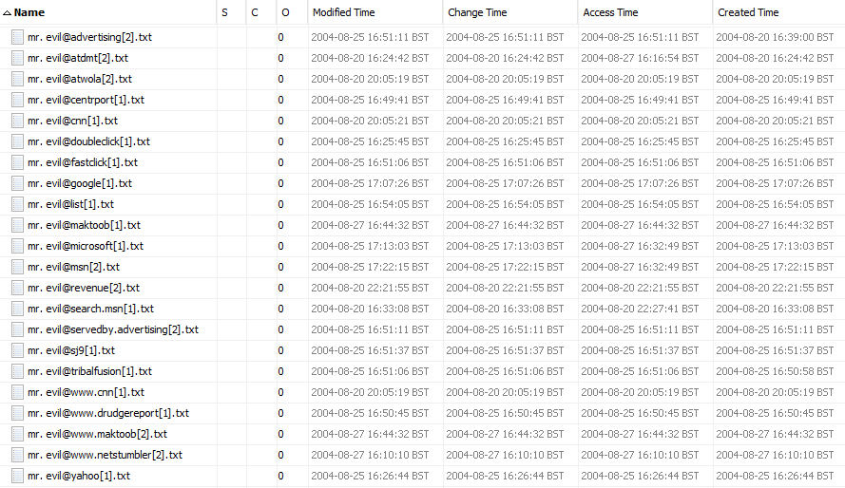

32 4.6.3 Cookie Logs

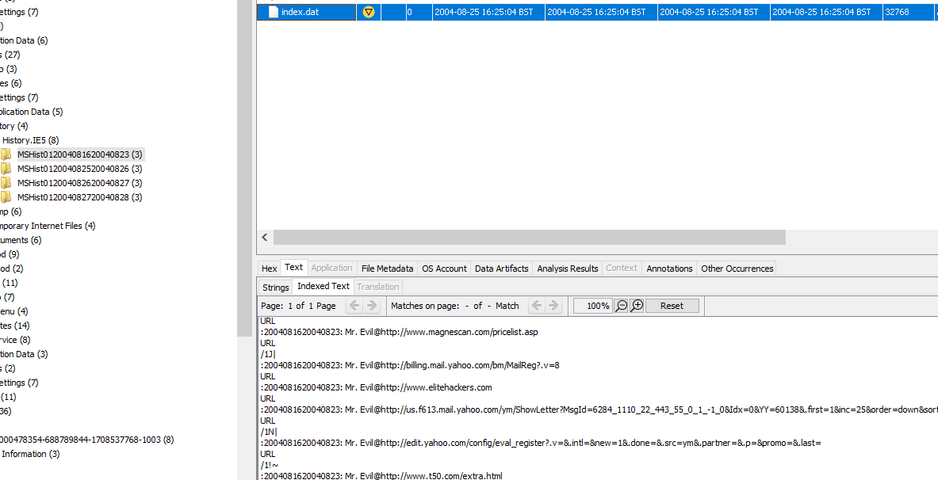

33 4.6.3 IE5 History Logs

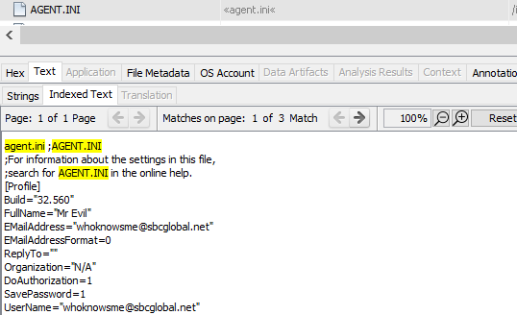

34 4.6.3 User Email

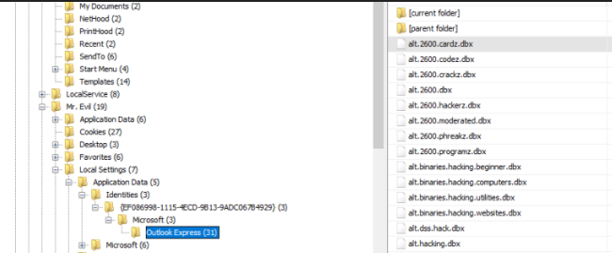

35 4.6.3 Subscribed Newsgroups

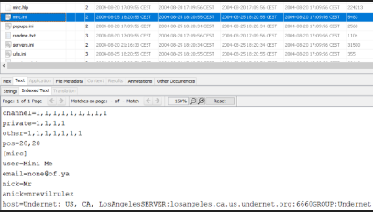

36 4.6.3 News Server Settings

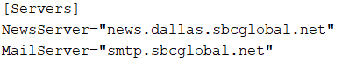

37 4.6.3 News/ Mail Server Settings

**4.6.4 EVIDENCE CLASS - MALICOUS SOFTWARE**

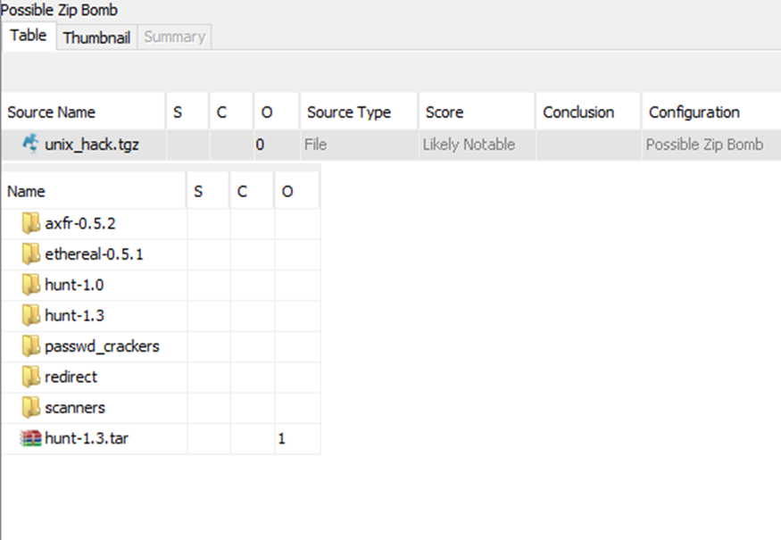

38 4.6.4 Zip Bomb Contents

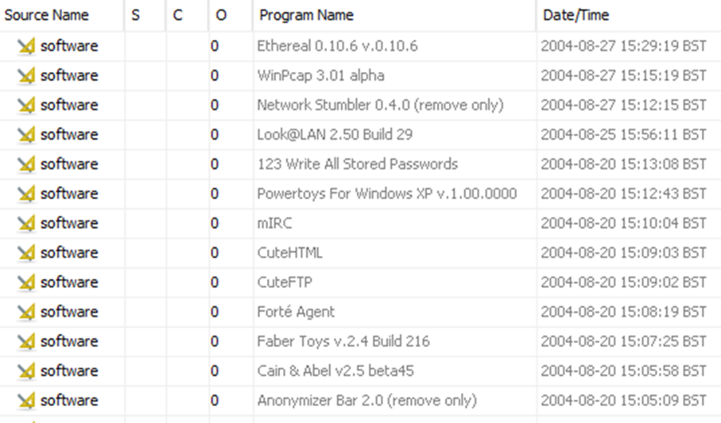

39 4.6.4 Malicious Software

**4.6.5 EVIDENCE CLASS - DATA COLLECTION**

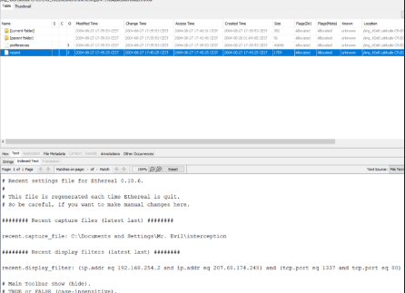

40 4.6.5 Ethereal IP and Port filter

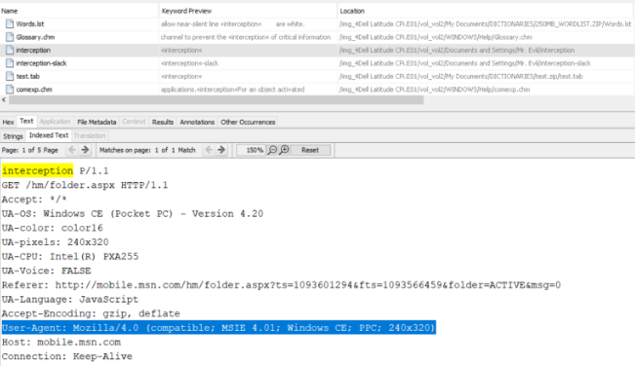

41 4.6.5 Device Interception

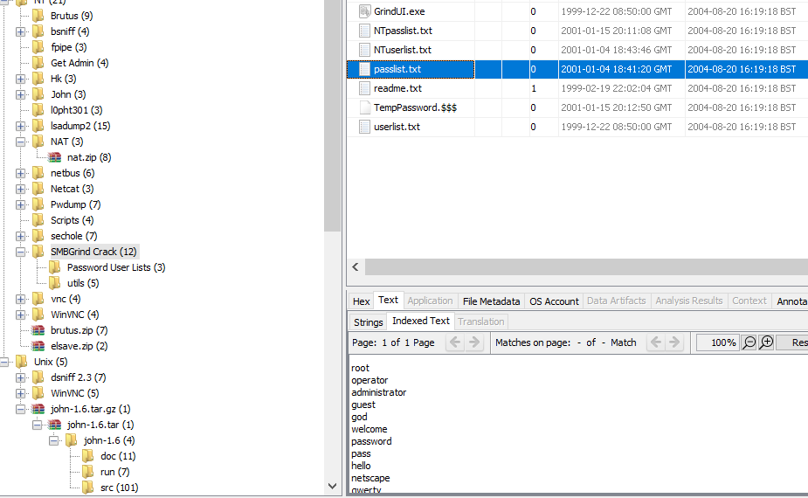

42 4.6.5 SMBGrind Crack Passwords

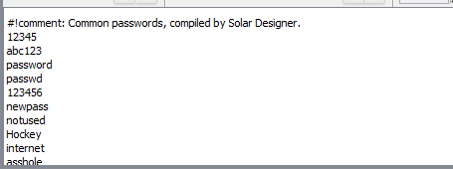

43 4.6.5 John the Ripper Passwords

**4.7 Event Timeline**

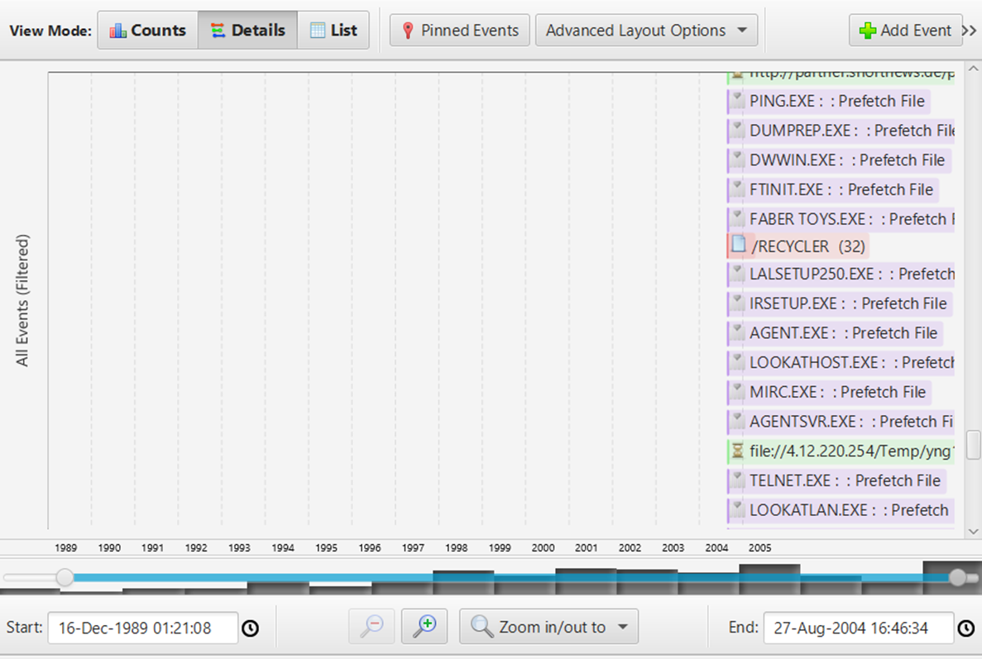

44 4.7 Application Event Timline

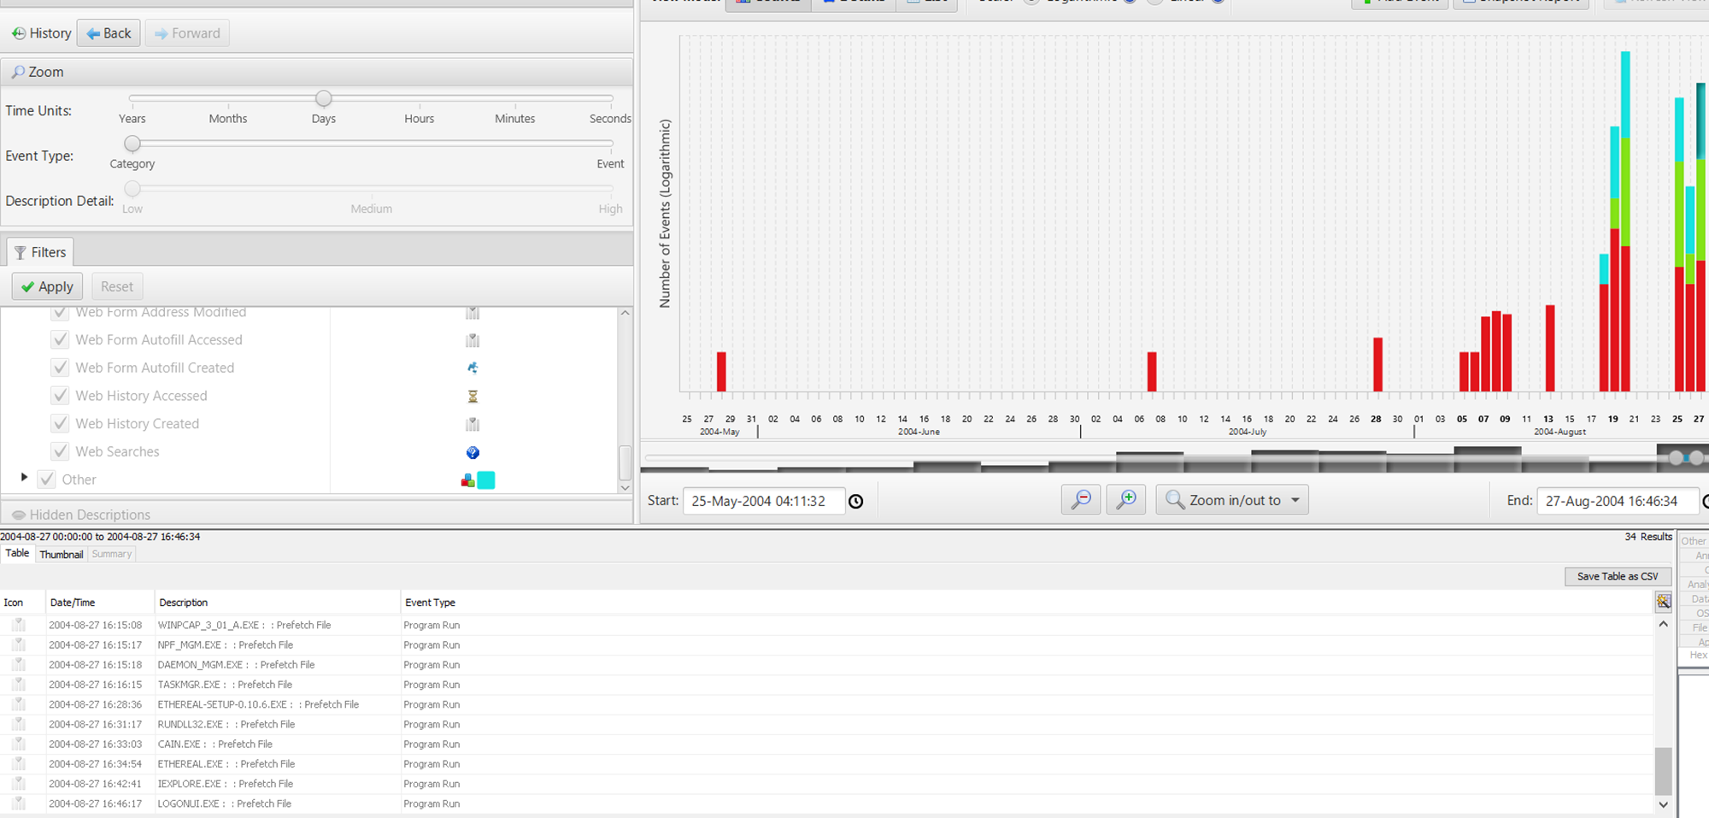

45 4.7 Detailed Timeline

**4.8 Audit**

